|  |  |
| --- | --- |
|  |  |
|  | **Appraisal Report**  **Multi-Family Walkup** **Property**  North Battleford Apartments  1101, 1121 109 St  North Battleford, Saskatchewan    **PREPARED FOR:**  **Kenneth Engler**    102109845 Saskatchewan Ltd.  1901, 1088 - 6th Ave SW  Calgary, AB T2P 5N3  **PREPARED BY:**  **Valta Property Valuations Ltd.**  300, 4838 Richard Road SW  Calgary, AB T3E 6L1  Office: 587-801-5151  www.valta.ca  Date of Valuation: October 17, 2025  Date of Report: November 20, 2025  **File No:** VAL251012 - 1 |
|  |

November 20, 2025

102109845 Saskatchewan Ltd.

1901, 1088 - 6th Ave SW,

Calgary, AB T2P 5N3

Attention: Kenneth Engler,

Re: As Stabilized (Fee Simple Estate) current market value for the property located at 1101, 1121 109 St, North Battleford, SK.

Valta Property Valuations Ltd. is proud to present the appraisal report that satisfies the agreed upon scope of work with 102109845 Saskatchewan Ltd. The purpose of this assignment is to provide the As Stabilized current market value of the property which at the time of inspection represents the improved property as of the effective date and leased up at market rental rates and operating costs for the property located at 1101, 1121 109 St, North Battleford, SK (herein referred to as the ‘subject property’).

The subject property, located at 1101, 1121 109 St, North Battleford, SK, is a multi-family, walkup property with improvements located in North Battleford The improvements are comprised of 2 total buildings, and consist of 10,204 square feet of net rentable area (NRA) as of the valuation date. The property, reportedly built in 1970; (1970 weighted) is approximately 100.0% occupied and features 16 units in a 2-story, garden style format.

Based upon our investigation of the real estate market and after considering all of the pertinent facts as set forth in the body of this appraisal report, as of the effective date, we have concluded the following:



Hypothetical Conditions

The use of a hypothetical condition(s) may have impacted the results of the assignment. The As Stabilized value has been developed based on the hypothetical condition that the subject property is fully leased at prevailing market rents and has achieved stabilized occupancy as of the effective date of the appraisal. Under this premise, no deductions are made for holding costs, rent loss, or lease-up expenses. In addition it is a hypothetical condition that all units could achieve current market rent levels and stabilized occupancy as of the effective date. In reality, as of the effective date, the property's existing lease terms reflect contract rents that are deemed to be below-market rents. For the purposes of this analysis, it is assumed that lease-up to market rent levels has occurred under typical market conditions, without undue delay or concessions exceeding market norms. If this assumption proves incorrect, such as market rents are not achievable the value conclusion may be materially impacted.

Extraordinary Assumptions

No Extraordinary Assumptions were made for this assignment.

Extraordinary Limiting Conditions

No Extraordinary Limiting Conditions were made for this assignment.

The report has been completed in accordance with the Canadian Uniform Standards of Professional Appraisal Practice (“CUSPAP”) adopted January 1, 2024. The full narrative appraisal report that follows sets forth the pertinent data and analyses leading to the conclusions presented herein. The appraisal requirements section of this report sets out the basis of the appraisal, definitions and the valuation methodology and must be read to gain a full understanding of the process.

If there are any specific questions or concerns regarding the attached appraisal report, or if Valta can be of additional assistance, please contact the individuals listed below.

Respectfully Submitted,

**VALTA PROPERTY VALUATIONS LTD.**

|  |  |
| --- | --- |
|  |  |
| Chris Chornohos, AACI, MRICS |  |
| Founder |  |
| chris.chornohos@valta.ca |  |
| AIC No: 902097 |  |

Introduction & Executive Summary 1

Property Overview 1

Photographs 4

Maps 9

Identification of Assignment 12

Property Analysis 17

Location 17

Site Details 18

Property Taxes & Assessment 23

Land Use & Planning 24

Description of the Improvements 26

Market Context 29

Economic Overviews 29

Multi-Family Market Overview 31

Highest & Best Use 32

Valuation Methodology 34

Income Approach 36

Direct Comparison Approach: Multifamily 50

Reconciliation of Value 61

Certification 63

Appendices 65

Contingent & Limiting Conditions 65

Definition of Terms 68

Qualifications of the Appraiser 72

Introduction & Executive Summary

Property Overview

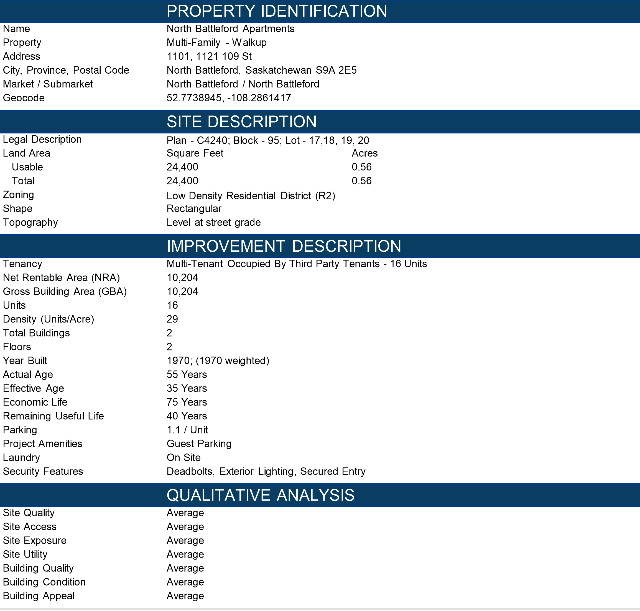

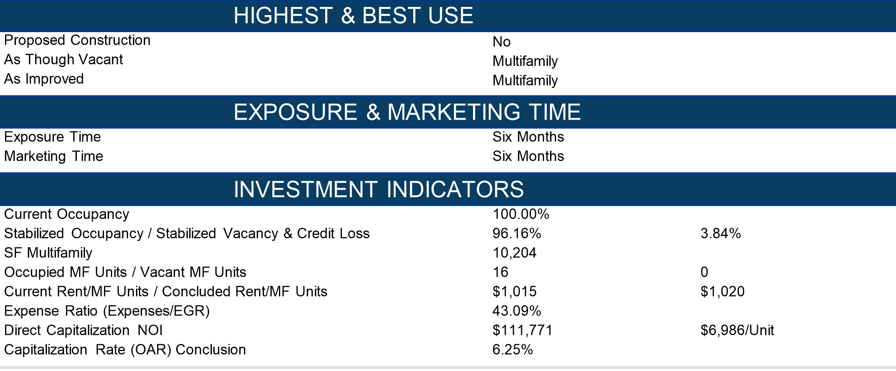

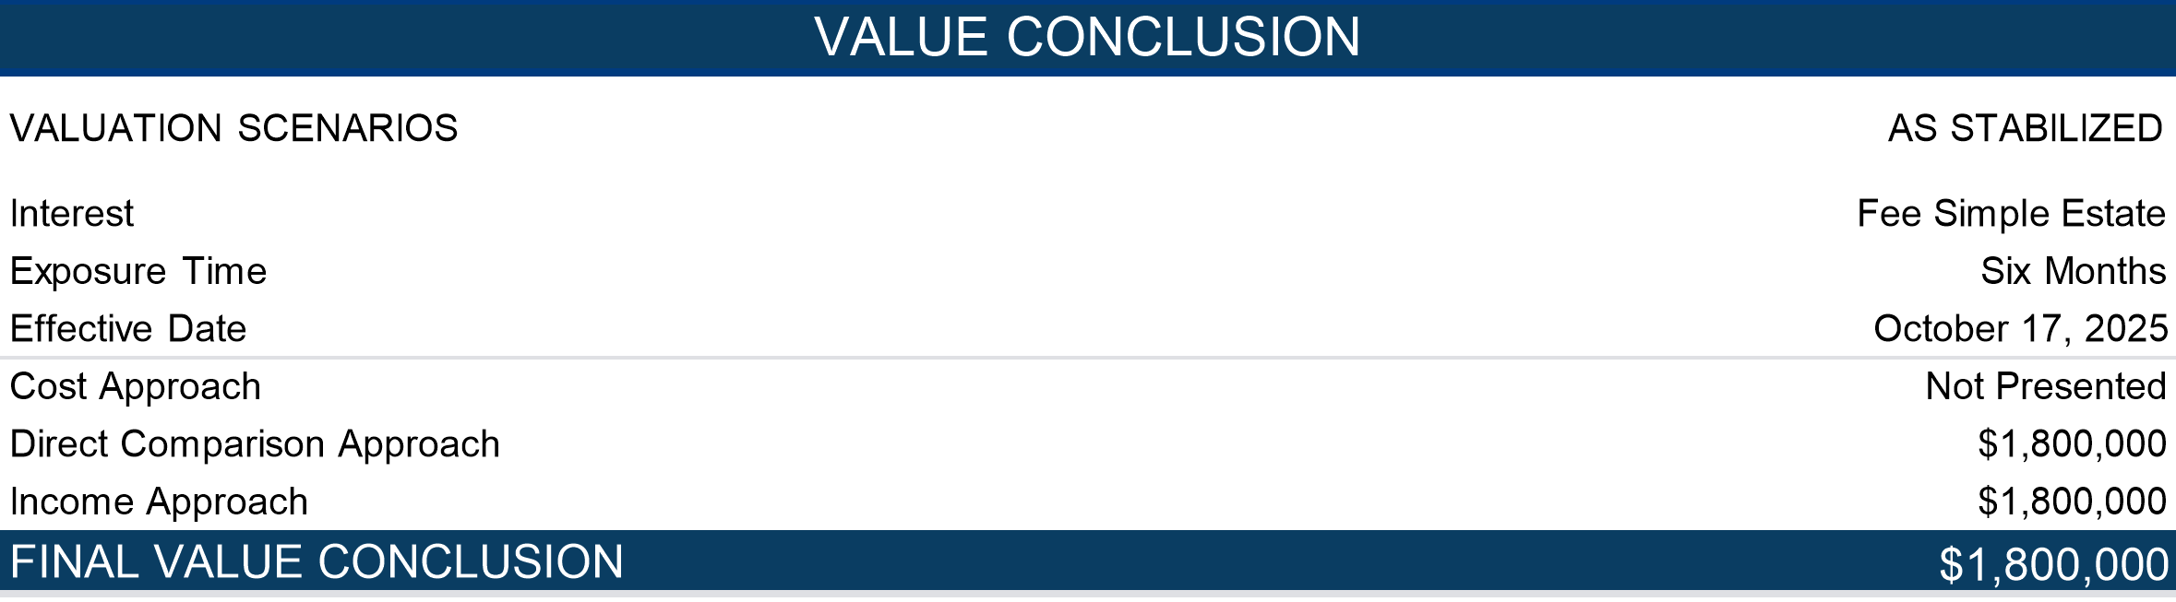

Hypothetical Conditions

The use of a hypothetical condition(s) may have impacted the results of the assignment. The As Stabilized value has been developed based on the hypothetical condition that the subject property is fully leased at prevailing market rents and has achieved stabilized occupancy as of the effective date of the appraisal. Under this premise, no deductions are made for holding costs, rent loss, or lease-up expenses. In addition it is a hypothetical condition that all units could achieve current market rent levels and stabilized occupancy as of the effective date. In reality, as of the effective date, the property's existing lease terms reflect contract rents that are deemed to be below-market rents. For the purposes of this analysis, it is assumed that lease-up to market rent levels has occurred under typical market conditions, without undue delay or concessions exceeding market norms. If this assumption proves incorrect, such as market rents are not achievable the value conclusion may be materially impacted.

Extraordinary Assumptions

No Extraordinary Assumptions were made for this assignment.

Extraordinary Limiting Conditions

No Extraordinary Limiting Conditions were made for this assignment.

Photographs

|  |  |
| --- | --- |
| A couple of people standing in front of a house  AI-generated content may be incorrect.  1101 - East Elevation | A white truck and a black car parked in front of a building  AI-generated content may be incorrect.  1101 - West Elevation |
| A road with yellow lines and trees  AI-generated content may be incorrect.  Street View Facing East - 11 Ave | A shadow of a person on a street  AI-generated content may be incorrect.  Street View Facing North - 109 St |
| A long hallway with white walls  AI-generated content may be incorrect.  1101 - Typical Hallwall | A staircase leading to a door  AI-generated content may be incorrect.  1101 - Typical Stairway |
| A bathroom with a sink and toilet  AI-generated content may be incorrect.  1101 - Typical Bathroom | A room with a wood floor and a wood floor  AI-generated content may be incorrect.  1101 - Typical Bedroom 1 |
| A bedroom with a bed and a laundry basket  AI-generated content may be incorrect.  1101 - Typical Bedroom 2 | A washing machine and dryer in a room  AI-generated content may be incorrect.  1101 - Electrical Room |
| A water heater with yellow pipes  AI-generated content may be incorrect.  1101 - Mechanical Room | A person standing in a kitchen  AI-generated content may be incorrect.  1101 - Typical Kitchen |
| A living room with a couch and a tv  AI-generated content may be incorrect.  1101 - Living Room | A building with trees and a car in front  AI-generated content may be incorrect.  1121 - West Elevation |
| A building with trees in the background  AI-generated content may be incorrect.  1121 - East Elevation | A long hallway with a light fixture  AI-generated content may be incorrect.  1121 - Typical Hallway |
| A staircase with a door open  AI-generated content may be incorrect.  1121 - Typical Stairway | A room with a wood floor and a door  AI-generated content may be incorrect.  1121 - Typical Living Room |
| A bathroom with a toilet and sink  AI-generated content may be incorrect.  1121 - Typical Bathroom | A kitchen with a white refrigerator and a white stove  AI-generated content may be incorrect.  1121 - Typical Kitchen |
| A room with a wood floor and a wood floor  AI-generated content may be incorrect.  1121 - Typical Bedroom | A laundry room with a sink and a trash can  AI-generated content may be incorrect.  1121 - Laundry Room |
| A close-up of a control panel  AI-generated content may be incorrect.  1121 - Electrical Room | A machine in a room  AI-generated content may be incorrect.  1121 - Typical Boiler |
| A large grey tank with white labels  AI-generated content may be incorrect.  1121 - Utility Room |  |

Maps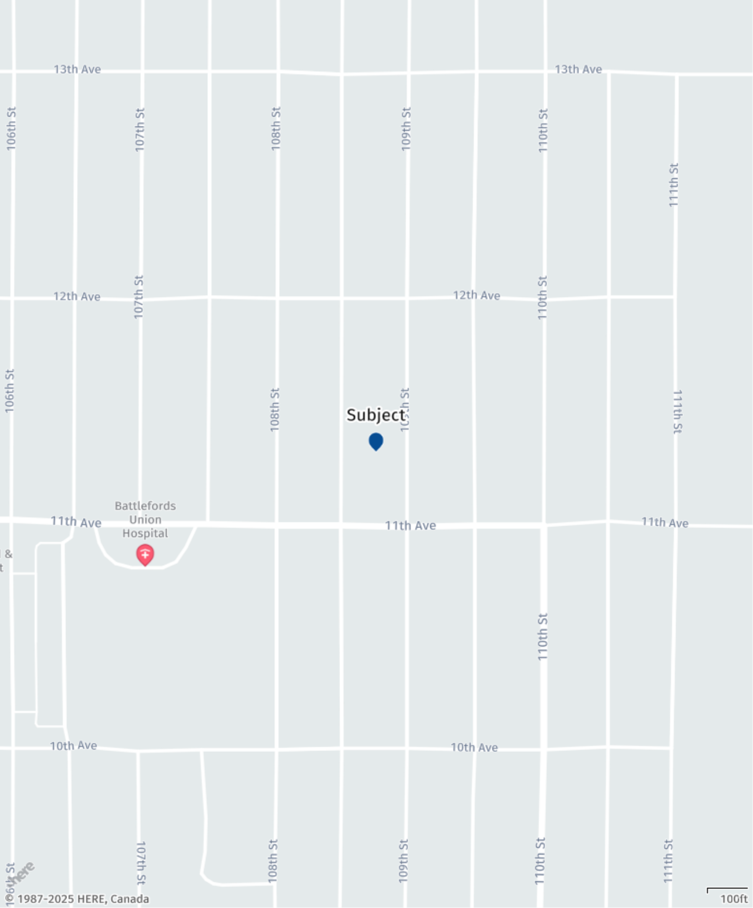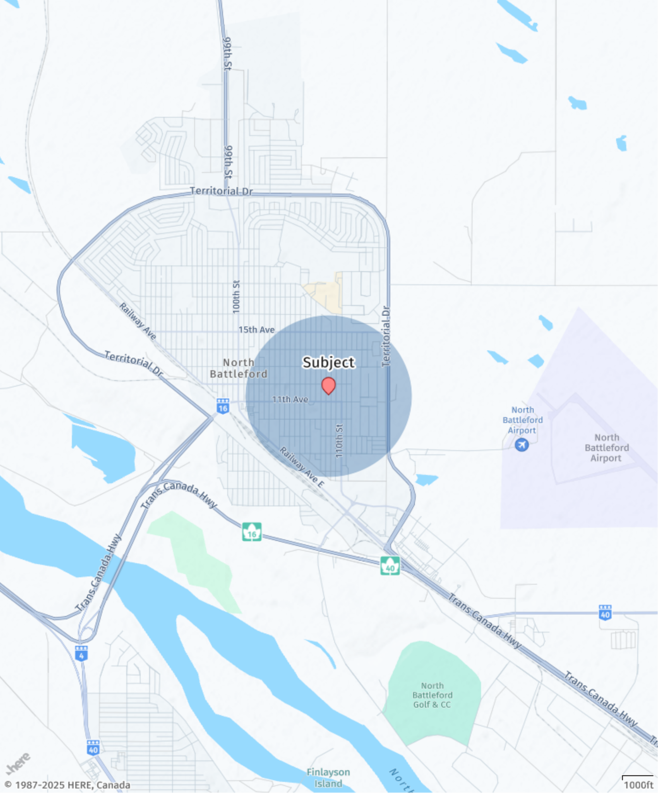

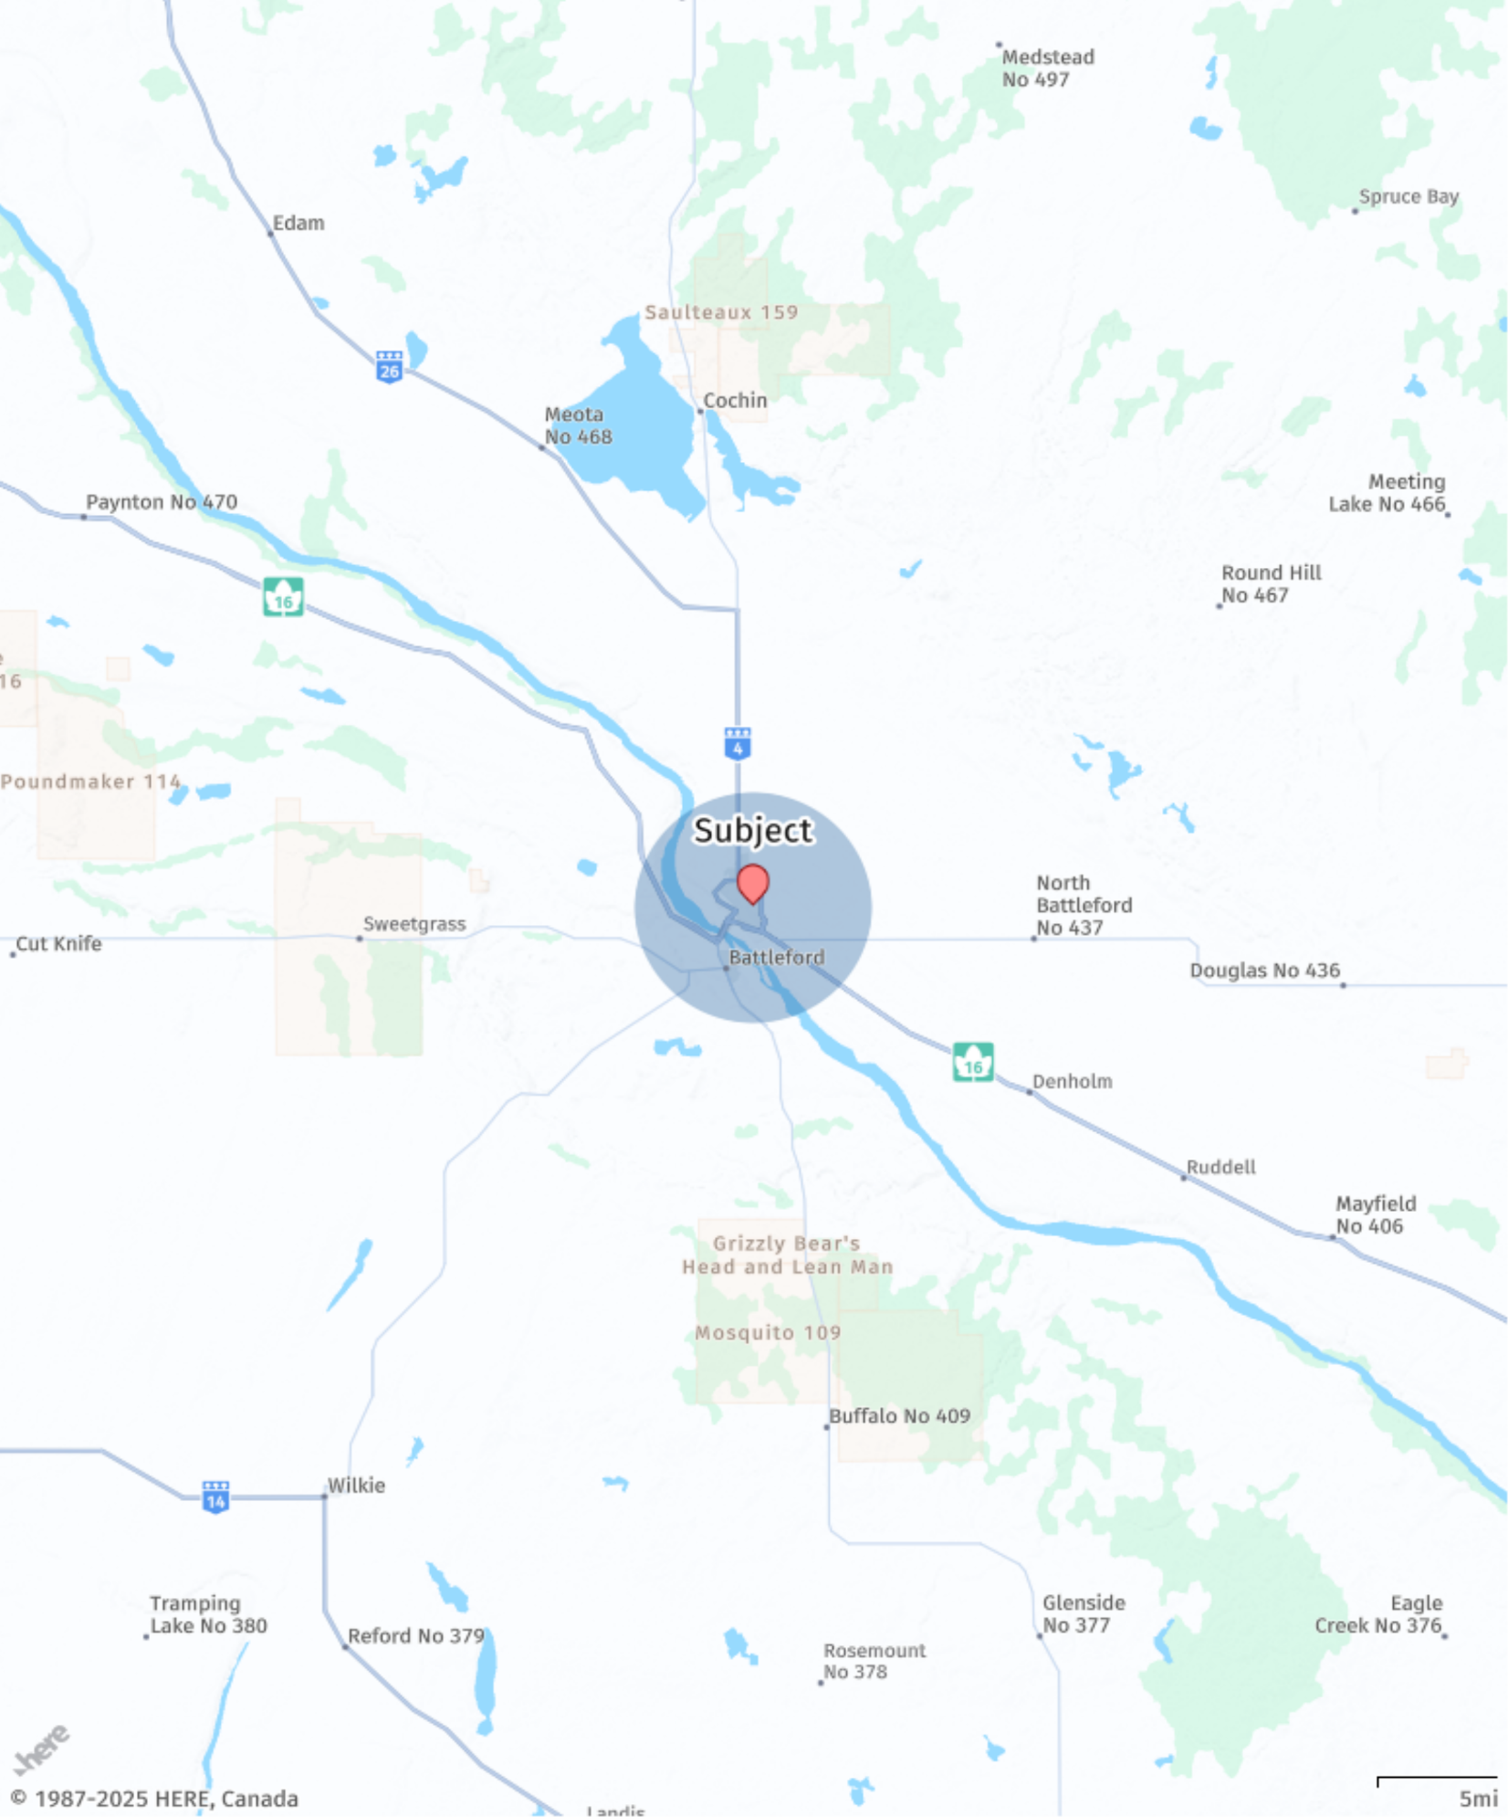

Identification of **Assignment**

Property Identification

The subject property, located at 1101, 1121 109 St, North Battleford, SK, is a multi-family, walkup property with improvements located in North Battleford

The improvements are comprised of 2 total buildings, and consist of 10,204 square feet of net rentable area (NRA) as of the valuation date. The property, reportedly built in 1970; (1970 weighted) is approximately 100.0% occupied and features 16 units in a 2-story, garden style format.

Legal Description

Plan - C4240; Block - 95; Lot - 17,18, 19, 20

Authorized Client Identification

The authorized client of this specific assignment is 102109845 Saskatchewan Ltd..

Authorized Use & Authorized Users

The authorized use of this report is for first mortgage financing purposes. 102109845 Saskatchewan Ltd. is the only authorized user of this report.

Effective Date of Value and Report Date

The effective date of value of this appraisal is October 17, 2025. The report date is November 20, 2025.

Inspection Date

October 17, 2025

Purpose

The purpose of this assignment is to provide the As Stabilized which at the time of inspection represents the existing improvements assuming stabilized occupancy as of the effective date for the property located at 1101, 1121 109 St, North Battleford, SK (herein referred to as the ‘subject property’).

Hypothetical Conditions

The use of a hypothetical condition(s) may have impacted the results of the assignment. The As Stabilized value has been developed based on the hypothetical condition that the subject property is fully leased at prevailing market rents and has achieved stabilized occupancy as of the effective date of the appraisal. Under this premise, no deductions are made for holding costs, rent loss, or lease-up expenses. In addition it is a hypothetical condition that all units could achieve current market rent levels and stabilized occupancy as of the effective date. In reality, as of the effective date, the property's existing lease terms reflect contract rents that are deemed to be below-market rents. For the purposes of this analysis, it is assumed that lease-up to market rent levels has occurred under typical market conditions, without undue delay or concessions exceeding market norms. If this assumption proves incorrect, such as market rents are not achievable the value conclusion may be materially impacted.

Extraordinary Assumptions

No Extraordinary Assumptions were made for this assignment.

Extraordinary Limiting Conditions

No Extraordinary Limiting Conditions were made for this assignment.

Property And Sales History

Current Owner

The subject property is currently under the ownership of 102109845 Saskatchewan Ltd.

Three-Year Sales History

Ownership of the subject property has not changed in the past three years. We are unaware of any pending sales or listing activity relating to the subject property.

Exposure & Marketing Time

An estimate of market value is related to the concept of reasonable exposure time. Exposure time is the property's estimated marketing time prior to a hypothetical sale at market value on the effective date of the appraisal. It is a retrospective function of asking price, property type, and past market conditions and encompasses not only adequate, sufficient and reasonable time but also adequate, sufficient and reasonable effort. Reasonable exposure time is a necessary element of a market value definition but is not a prediction of a specific date of sale.

In appraisal theory and practice, there is a distinction relating to the perspective between exposure time and marketing time. Exposure time is presumed to precede the effective date of appraisal whereas marketing time is presumed to succeed the effective date. Marketing time is a prospective function of asking price, property type, and anticipated market conditions. The exposure period assumes the following:

* The property was extensively marketed. Potential purchasers could inspect the property at will.
* The owner provided interested agents with any and all relevant property information.
* Negotiations of any offers to purchase were performed in a timely manner.
* The property was maintained at a physical status equivalent to its present condition.
* Market level financing was readily available.
* The seller was not under duress.

A marketing time estimate is a forecast of a future occurrence. History should be considered as a guide, but anticipation of future events and market circumstances should be the prime determinant.

Noting the subject property’s physical, legal, economic and market characteristics, which are described further in this report, we have concluded a reasonable estimate of **exposure and marketing time** for the subject property to be six months.

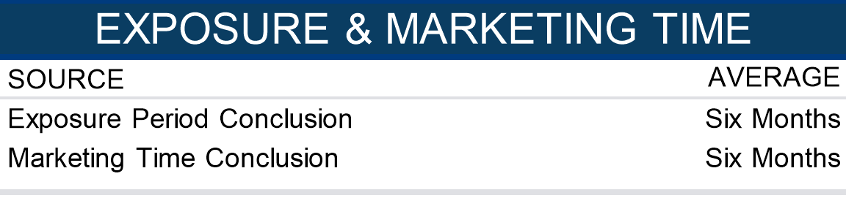

Definition of Market Value

According to the January 1, 2024 version of the Canadian Uniform Standards of Professional Appraisal Practice (CUSPAP), market value is defined as:

“The most probable price, as of a specified date, in cash, or in terms equivalent to cash, or in other precisely revealed terms, for which the specified property rights should sell after reasonable exposure in a competitive market under all conditions requisite to a fair sale, with the buyer and the seller each acting prudently, knowledgeably, and for self-interest, and assuming that neither is under undue duress.”

Implicit in this definition are the consummation of a sale as of the specified date and the passing of title from seller to buyer under conditions whereby:

1. buyer and seller are typically motivated;
2. both parties are well informed or well advised, and acting in what they consider their best interests;
3. a reasonable time is allowed for exposure in the open market;
4. payment is made in terms of cash in Canadian dollars or in terms of financial arrangements comparable thereto;
5. the price represents the normal consideration for the property sold unaffected by special or creative financing or sales concessions granted by anyone associated with the sale.

Property Rights Appraised

The property rights appraised constitute the fee simple estate interest.

Fee Simple Interest

Absolute ownership unencumbered by any other interest or estate, subject only to the limitations imposed by the governmental powers of taxation, eminent domain, police power and escheat. The subject multifamily property is appraised under the fee simple interest, as residential tenancies are typically short-term in nature and do not constitute long-term encumbrances on the estate that would give rise to a leased fee interest.

Value Scenarios

Current Value

Current Value Opinion refers to an effective date at the time of inspection or, at some other date within a reasonably short period of time from the date of inspection when market conditions have not or are not expected to have changed.

Scope of Work

The scope of work for this appraisal assignment is outlined below:

* The appraisal analyzes legal and physical features of the subject including site size, improvement size, site zoning, easements, encumbrances, site access and site exposure.
* The appraisal includes a market analysis for the North Battleford market and North Battleford submarket using vacancy and rent data. Conclusions were drawn for the subject’s competitive position given its physical and locational features, current market conditions and external influences.
* Research of recent sale and rent comparables. Examined market conditions and analyzed their potential effect on the various properties.
* The appraisal includes a Highest and Best Use analysis and conclusions have been completed for the highest and best use of the subject property As Though Vacant and As Improved. The analysis considered legal, locational, physical and financial feasibility characteristics of the subject site and existing improvements.
* In selecting applicable approaches to value, the appraiser s considered the agreed upon appraisal scope and assessed the applicability of each traditional approach given the subject’s characteristics and the intended use of the appraisal. As a result, this appraisal developed Direct Comparison and Income (Direct Capitalization) Approaches. The values presented represent the As Stabilized (Fee Simple Estate).
* The assignment was prepared as an Appraisal Report in accordance with CUSPAP, with the analysis stated within the document and representing a fully described level of analysis.
* The author of this report has the knowledge and experience to complete this assignment competently.

The following work was not undertaken as it was not required for credible results within the scope of this concise assignment in conformity with CUSPAP 2024.

* Environmental reports, building condition assessments, and title searches were not reviewed by the appraiser and are assumed to be satisfactory unless otherwise stated.
* The appraiser did not review title documents or legal encumbrances other than zoning information provided by municipal sources.
* No verification of building permits, code compliance, or outstanding orders was undertaken.
* Rent rolls, leases and operating statements, were accepted as accurate without audit or verification.
* Discussions with market participants were limited to informal inquiries and published sources.

This appraisal was completed in conformity with the CUSPAP 2024 Appraisal Standard and the Reporting Standard for a Concise Report, which requires inclusion of all relevant information necessary to produce a credible result, summarized in narrative form with supporting detail in the work file.

Assistance Provided

Paul Liboiron of Insight Home Inspections Ltd., a member of Alberta Professional Home Inspectors Society provided real property appraisal assistance to the appraisers signing this certification. Assistance provided includes property inspection. Paul Liboiron is registered as a non-member with the AIC to provide professional assistance with real property inspection.

Sources of Information

The following sources were contacted to obtain relevant information:

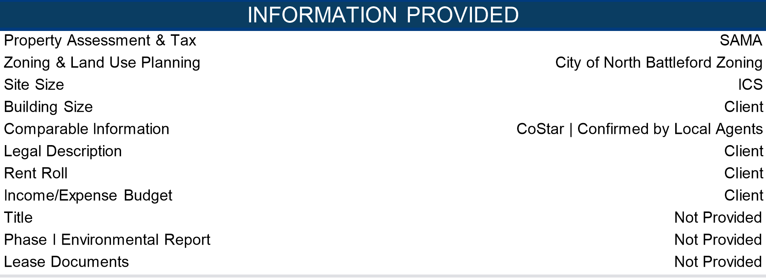

The lack of the unavailable items could affect the results of this analysis. As part of the general assumptions and limiting conditions, the subject is assumed to have no adverse easements, significant items of deferred maintenance, or be impacted by adverse environmental conditions.

Subject Property Inspection

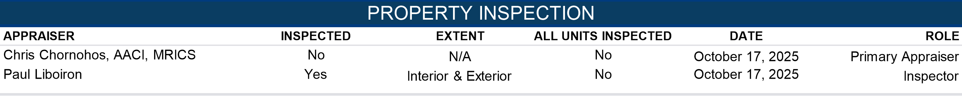

Personal Property & Business Intangible

There is no personal property (FF&E) included in this valuation. There is not any business or intangible value included in the value conclusion reported herein.

Property Analysis

Location

The subject property is located in North Battleford, Saskatchewan, in a centrally situated residential area near key commercial corridors and the downtown core.

**Access**  
The property fronts 109 Street with convenient connections to major arterials including 100th Street/Highway 4 (north–south route to downtown and Highway 16) and Territorial Drive (east–west/loop connecting retail and services).

**Public Transportation**  
Local bus service operates on nearby corridors such as 100th Street and Territorial Drive, providing direct access to downtown, retail centres, and community facilities.

**Walk/Bike/Transit Scores**  
The immediate area offers moderate walkability and cycling potential, with an estimated Walk Score around 60, Transit Score near 35, and Bike Score around 55, reflecting car-optional access for daily needs.

**Local Area**  
The neighbourhood is a mature urban district with a mix of single-family homes, small multi-unit buildings, and local businesses. Residents are close to grocery, cafés, and parks, with recreation and services clustered along 100th Street and Territorial Drive. The location balances neighbourhood livability with quick access to city amenities and employment nodes.

**Nearby Schools**  
• Bready School (K–7, public)  
• Connaught School (K–7, public)  
• North Battleford Comprehensive High School (Grades 10–12, public)  
• John Paul II Collegiate (Grades 9–12, Catholic)  
• St. Mary School (K–7, Catholic)

Site Details

The subject property consists of one parcel with a total site area of 24,400 SF (0.56 AC) which is based on information obtained from ICS. For the purposes of this report, we have relied on this site area and reserve the right to amend our analysis upon receipt of a formal legal plan. The following summarizes the salient characteristics of the subject site.

**Address** 1101, 1121 109 St, North Battleford, Saskatchewan

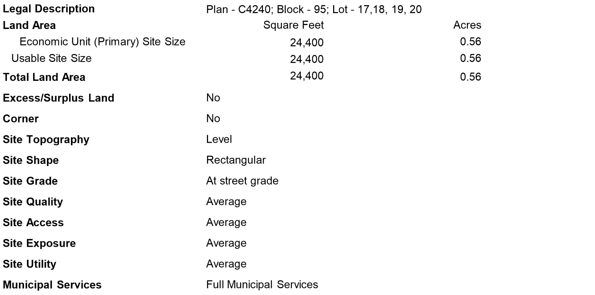

**Adjacent Properties**

North Residential

South Residential

East Residential

West Residential

**Accessibility** Access to the subject site is considered average overall.

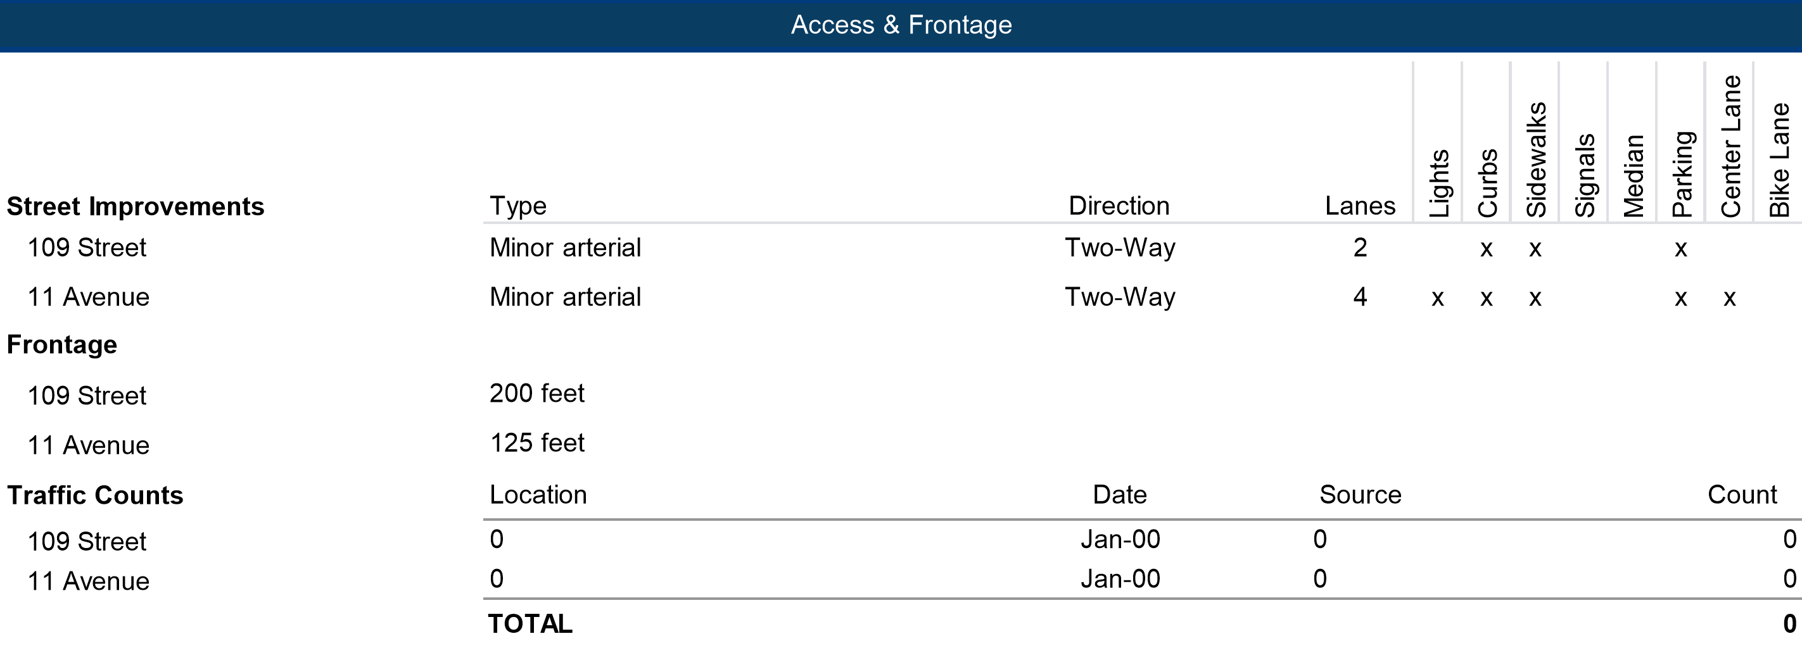

Exposure & Visibility

Exposure of the subject is average noting frontage on 109 Street & 11 Avenue

Easements

A legal opinion regarding title information was not provided or commissioned in conjunction with this assignment. Under the scope of this appraisal, it is assumed that any legal notations and registered charges on title do not adversely affect the highest and best use of the subject property as described herein, unless otherwise noted. If there is any concern on the part of the reader with respect to the status of title, we recommend a legal opinion be obtained. A copy of the subject property title has been inserted in the appendix to this report if further information is required.

Soils

We have not undertaken a detailed soil analysis and we are not qualified to comment on soil conditions. As such, the soils are assumed to be similar to other lands in the area and suitable in drainage qualities and load bearing capacity to support the existing development.

Hazardous Waste

Based on a review of an independent investigation to determine the presence or absence of toxins on the subject property, none are present. If questions arise, the reader is strongly cautioned to seek qualified professional assistance in this matter. Please see the Assumptions and Limiting Conditions for a full disclaimer.

Site Rating

Overall, the subject site is considered average as a multi-family site in terms of its location, exposure and access to employment, education and shopping centers, based on its location along a minor arterial.

Site Conclusion

In conclusion, the site’s physical characteristics appear to be supportive of the subject’s current use and there were no significant detriments discovered that would inhibit development in accordance with its highest and best use.

Site Plans – Lot 17

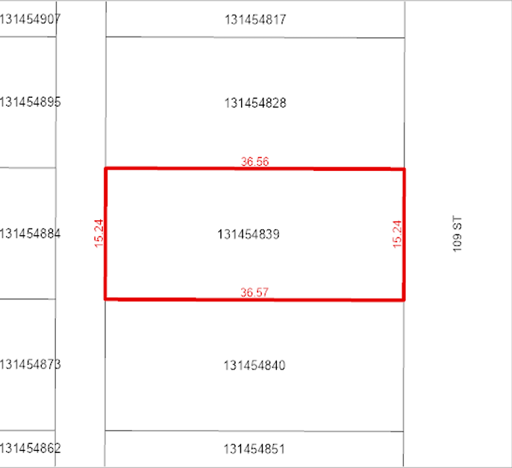

Site Plans – Lot 18

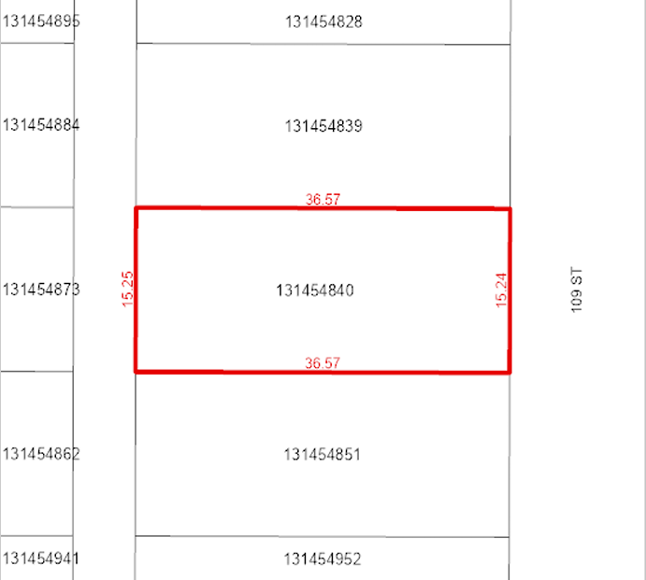

Property Taxes & Assessment

Real Estate Taxes

The subject’s assessment and taxes are shown in the following table:

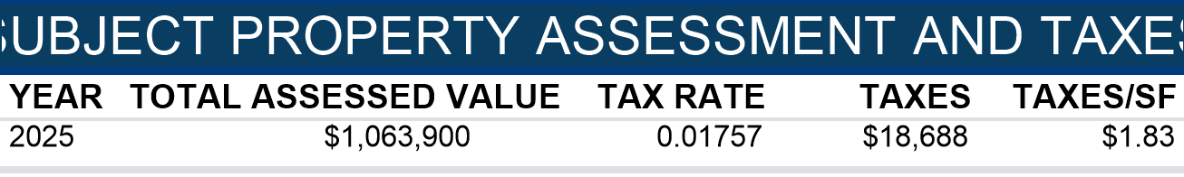

Taxation & Assessment Commentary

The assessed value is below the value concluded herein, a tax assessment appeal is not warranted.

The assessed value is lower than our valuation herein. Smaller markets tend to under assess real property assets in comparison to larger markets.

Land Use & Planning

The subject is located in the Low Density Residential District (R2) zoning area which is a Low Density Residential District.

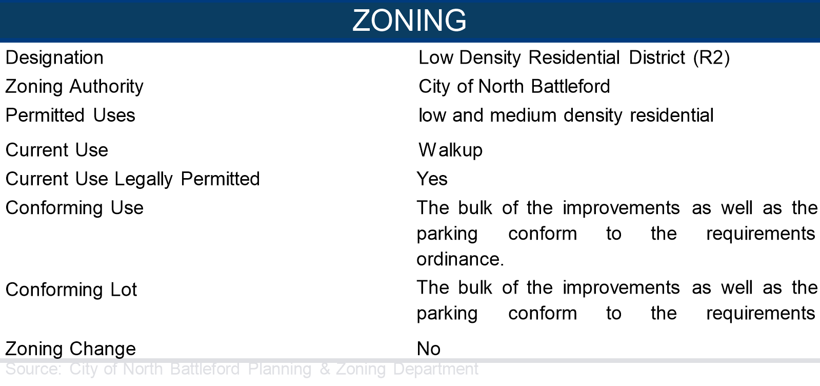

Zoning Conclusion

The current use for the subject property is walkup and is a permitted use based on the current zoning guidelines. No zoning change is believed to be imminent. Based on the foregoing, it appears that the subject’s improvements are a legally conforming use of the subject site.

Zoning Map

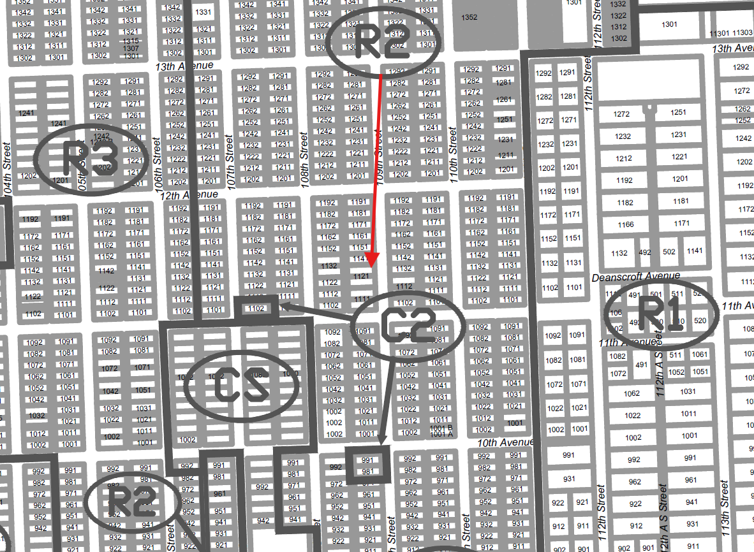

Description of the Improvements

The information presented below is a basic description of the existing improvements that are used in the valuation of the property. Reliance is placed on information provided by sources deemed dependable for this analysis. It is assumed that there are no hidden defects, and that all structural components are functional and operational, unless otherwise noted. If questions arise regarding the integrity of the improvements or their operational components, it may be necessary to consult additional professional resources. The sizes are based on the information provided by the client and from public sources.

Overview

The subject property, located at 1101, 1121 109 St, North Battleford, SK, is a multi-family, walkup property with improvements located in North Battleford

The improvements are comprised of 2 total buildings, and consist of 10,204 square feet of net rentable area (NRA) as of the valuation date. The property, reportedly built in 1970; (1970 weighted) is approximately 100.0% occupied and features 16 units in a 2-story, garden style format.

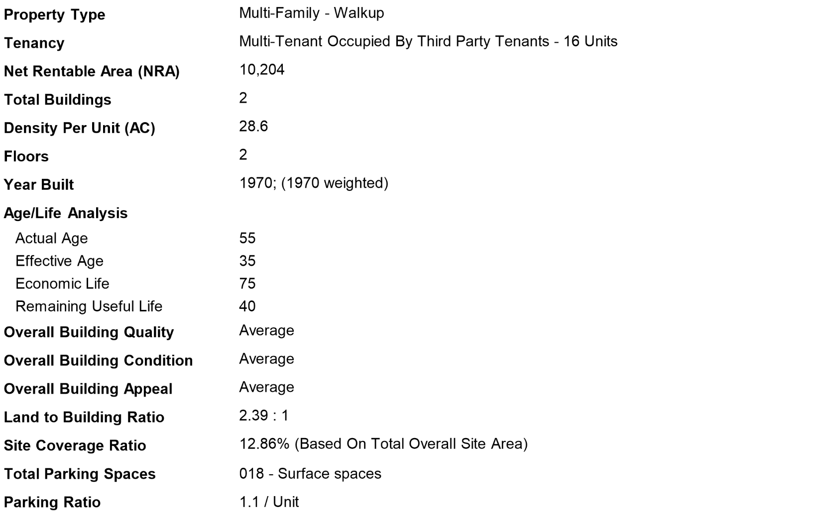

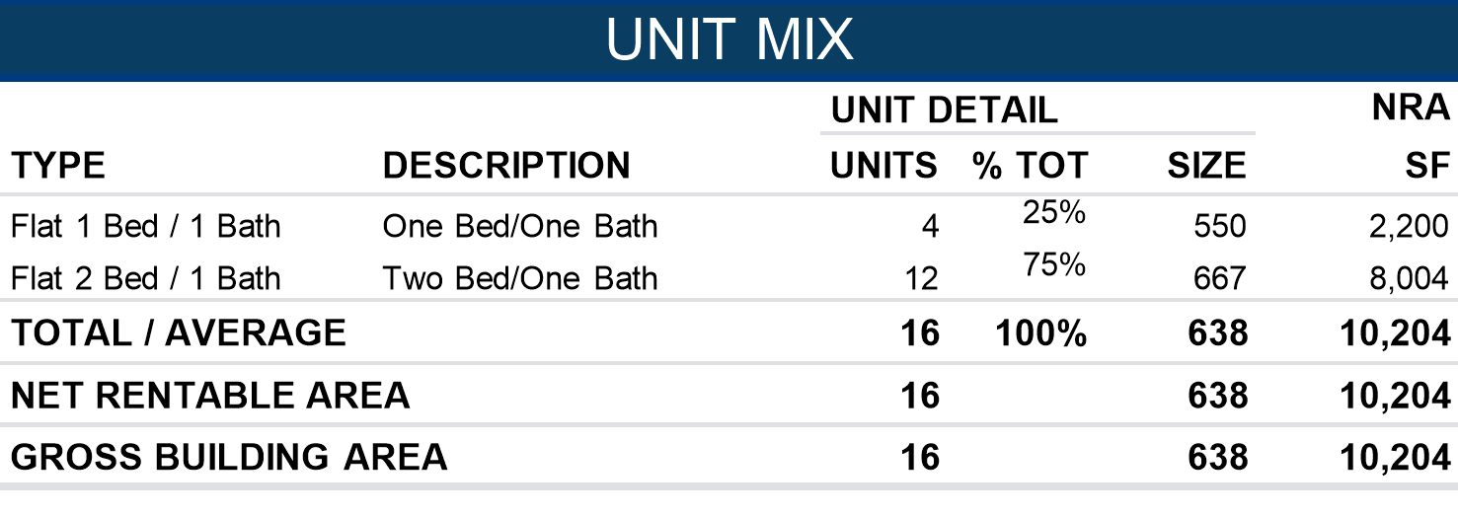

Building Description

|  |  |
| --- | --- |
| **COMPONENT** | **DESCRIPTION** |
| **Project Amenities** | Guest Parking |
| **Unit Amenities** | Deck/Patio, Range/Stove, Refrigerator |
| **Laundry** | On Site |
| **Security Features** | Deadbolts, Exterior Lighting, Secured Entry |
| **Foundation** | Concrete footings and walls; |
| **Exterior Walls/Framing** | 1121 - Brick, 1101 Stucco/Wood frame; |
| **Roof** | Flat built up membrane; |
| **Elevator** | None; |
| **Heating & AC (HVAC)** | 1101 - 8 Furnaces, 1121 - Boilers with baseboard radiant heat; |
| **Insulation** | Fiberglass; |
| **Lighting** | Various; |
| **Electrical** | Individually metered; |
| **Interior Walls** | Painted drywall; |
| **Doors and Windows** | Wood interior & metal exterior doors/Vinyl or metal frame double pane glazing; |
| **Ceilings** | Textured drywall; |
| **Plumbing** | Standard; |
| **Floor Covering** | Combination of carpet, tile, vinyl tile and laminate hard wood; |
| **Fire Protection** | None; |
| **Interior Finish/Build-Out** | Standard rental finishes; |
| **Site Improvements** | Gravel parking, sidewalks, and curbs; |
| **Landscaping** | Landscaping around the building perimeter to consist of shrubs and trees. The landscaping as proposed is well established and well maintained. |
| **Parking** | The subject provides 18 parking spaces and is therefore conforming to zoning requirements. The parking ratio of 1.1 per unit is within the typical range of spaces per unit and within zoning requirements. |
| **Site Coverage Ratio** | 12.9% (3,138 SF footprint / 24,400 SF site), which is within market standards (20-35%) for similar walkup buildings in the area. |
| **Functional Design** | The building features a functional Walkup design with typical site coverage and adequate off-street parking. |
| **Hazardous Materials** | A Phase I report was not provided. This appraisal assumes that the improvements are constructed free of all hazardous waste and toxic materials, including (but not limited to) unseen asbestos and mold. Please refer to the Assumptions and Limiting Conditions section regarding this issue. |

Market Context

Economic Overviews

National

Canada’s economy in 2025 finds itself in a delicate balance: modest growth, contained inflation, but significant uncertainty from external trade and global energy markets. The Bank of Canada expects real GDP growth to recover toward 1.8% in 2025–2026, after a softer 2024. Inflation is projected to remain close to the 2% target, aided by moderating rent inflation and easing supply pressures. On the positive side, residential investment and housing construction are expected to lead growth, supported by past rate cuts, pent-up demand, and government incentives for rental construction. Meanwhile, energy and export infrastructure especially pipeline capacity and LNG projects could provide a lift to Canadian exports. However, the risk of U.S. tariffs and a weakening labour market looms as a drag. In sum, Canada’s 2025 is expected to be a moderating year, with growth stabilizing, inflation under control, and selective pockets of strength in housing, energy, and exports. The upside hinges on trade resolution and external demand; the downside centers on global turmoil, policy missteps, or weakening domestic demand.



Provincial

Saskatchewan

Saskatchewan’s economy in 2025 is defined by steady growth, strong resource activity, and an improving housing sector. Real GDP is expanding at a moderate pace, supported by agriculture, potash, and oil production, while inflation has cooled to below 2%, easing cost pressures on households. Employment conditions remain relatively solid, with unemployment near 5.5–6%, and consumer demand is buoyed by wage gains and population growth. Housing starts have surged, reflecting confidence in residential markets and rising construction momentum. On the investment front, resource projects and infrastructure spending provide additional stability, and the province maintains a solid AA credit rating with a balanced budget outlook. Risks remain tied to commodity markets, especially oil prices and global agricultural demand, along with challenges in attracting and retaining skilled labour. In sum, Saskatchewan’s 2025 outlook is stable and resource-anchored, with healthy construction activity and moderate inflation, but still exposed to the swings of global markets.



Multi-Family Market Overview

Saskatchewan

Saskatchewan’s rental markets entered 2025 with improving balance. Vacancy rates approached 3 %, reflecting steady new completions and a cooling inflow of migrants. Rents plateaued after outsized 2023–24 gains, with most urban landlords holding rates or offering small concessions. Construction activity remains healthy, supported by government and CMHC financing programs. Affordability remains better than the national average, yet rising rent-to-income ratios signal growing strain among lower-income tenants.



Highest & Best Use

Introduction

The highest and best use of a property is defined as the legally permissible, physically possible, financially feasible, and maximally productive use that results in the highest value. This analysis serves as the foundation for the valuation process and determines the most reasonable and profitable use of the property to support its maximum present value.

The analysis is completed through the following four steps:

* Step 1: Highest and Best Use as Vacant
* Step 2: Determination of Ideal Improvements
* Step 3: Highest and Best Use as Proposed
* Step 4: Final Conclusion

This structured approach ensures a comprehensive evaluation of the property, moving from a broad market perspective to a focused determination of its optimal use.

This section develops the highest and best use of the subject property As Though Vacant and As Improved.

As Though Vacant Analysis

In this section the highest and best use of the subject as though vacant is concluded after taking into consideration financial feasibility, maximal productivity, marketability, legal, and physical factors.

Legally Permissible

Private restrictions, zoning, building codes, historic district controls, and environmental regulations are considered, if applicable to the subject site. The legal factors influencing the highest and best use of the subject site are primarily government regulations such as zoning ordinances. Permitted uses of the subject’s Low Density Residential District (R2) zoning include low and medium density residential. A zoning change is not likely; therefore, uses outside of those permitted by the R2 zoning are not considered moving forward in the as though vacant analysis.

Physically Possible

The test of what is physically possible for the subject site considers physical and locational characteristics that influence its highest and best use. In terms of physical features, the subject site totals 0.5601-acres (24,400 SF), it is rectangular in shape and has a level topography. The site has average exposure and average overall access. There are no physical limitations that would prohibit development of any of the by-right uses on the site.

Financial Feasibility

Based on the analysis of the subject’s market and an examination of costs and investment metrics and real estate market attributes, a multifamily building would likely have a value commensurate with its costs and requisite developer’s profit.

Maximum Productivity

There is only one use that creates value and at the same time conforms to the requirements of the first three tests. Financial feasibility, maximal productivity, marketability, legal, and physical factors have been considered and the highest and best use of the subject site as though vacant and is concluded to be a multifamily use.

As Improved Analysis

The legal factors influencing the highest and best use of the subject property are primarily governmental regulations such as zoning and building codes. The subject’s improvements were constructed in 1970; (1970 weighted) and are a legal, conforming use. The physical and locational characteristics of the subject improvements have been previously discussed in this report. The project is of average quality construction and average condition, with adequate site coverage and parking ratios.

The five possible alternative treatments of the property are redevelopment/demolition (not warranted as the improvements contribute substantial value to the site), expansion (not applicable, no excess or surplus land), renovation (not warranted), conversion (not warranted), and continued use "as-is" use. Given the underlying market conditions and activity, it appears that the multifamily use As Improved has a sufficient degree of financial feasibility.

Among the five alternative uses, a continuation of the multifamily use is the Highest and Best Use of the subject is As Improved.

Most Probable Buyer

Based on the type of property and the income generating potential of the improvements, it is our opinion that the most probable buyer for the subject would be a local or regional investor As Improved,

Valuation Methodology

In traditional valuation theory, the three approaches to estimating the value of an asset are the cost approach, sales comparison approach, and income capitalization approach. Each approach assumes valuation of the property at the property’s highest and best use. From the indications of these analyses, an opinion of value is reached based upon expert judgment within the outline of the appraisal process.

Land Valuation

Characteristics specific to the subject property do not warrant that a site value is developed.

Cost Approach

The cost approach considers the cost to replace the proposed improvements, less accrued depreciation, plus the market value of the land. The cost approach is based on the understanding that market participants relate value to cost. The value of the property is derived by adding the estimated value of the land to the current cost of constructing a reproduction or replacement for the improvements and then subtracting the amount of depreciation in the structure from all causes. Profit for coordination by the entrepreneur is included in the value indication. Considering the limited applicability of this approach in relation to the subject property's characteristics, we have not undertaken the Cost Approach. The Cost Approach has limited applicability due to the age of the improvements and lack of market based data to support an estimate of accrued depreciation. Based on the preceding information, the Cost Approach has not been undertaken as part of this analysis.

Investors typically do not place emphasis on replacement cost in establishing value for investment properties. The exclusion of the Cost Approach does not diminish the credibility of the value conclusion.

Sales Comparison Approach

The sales comparison approach estimates value based on what other purchasers and sellers in the market have agreed to as price for comparable properties. This approach is based upon the principle of substitution, which states that the limits of prices, rents, and rates tend to be set by the prevailing prices, rents, and rates of equally desirable substitutes. In conducting the sales comparison approach, we gather data on reasonably substitutable properties and make adjustments for transactional and property characteristics. The resulting adjusted prices lead to an estimate of the price one might expect to realize upon sale of the property.

We have undertaken the Direct Comparison Approach as part of this assignment. Considering the applicability of this approach in relation to the subject property's characteristics, we consider the application of this approach to be warranted.

Income Capitalization Approach

The income capitalization approach (“income approach”) simulates the reasoning of an investor who views the cash flows that would result from the anticipated revenue and expense on a property throughout its lifetime. The net income developed in our analysis is the balance of potential income remaining after vacancy and collection loss, and operating expenses. This net income is then capitalized at an appropriate rate to derive an estimate of value or discounted by an appropriate yield rate over a typical projection period in a discounted cash flow analysis. Thus, two key steps are involved: (1) estimating the net income applicable to the subject and (2) choosing appropriate capitalization rates and discount rates. The appropriate rates are ones that will provide both a return on the investment and a return of the investment over the life of the particular property.

We have undertaken the Income Approach as part of this assignment. The subject property comprises an income generating asset and as such, we consider the inclusion of this approach warranted. In undertaking this approach, we have relied on the Direct Capitalization method only as the Discounted Cash Flow method does not contribute substantially to estimating the market value of the subject property beyond the Direct Capitalization method.

Correlation and Conclusion

upon scope with the authorized client, the subject’s specific characteristics and the interest appraised, this appraisal developed Direct Comparison and Income (Direct Capitalization) Approaches. The values presented represent the As Stabilized (Fee Simple Estate). This appraisal does not develop the Cost Approach, the impact of which is addressed in the reconciliation section.

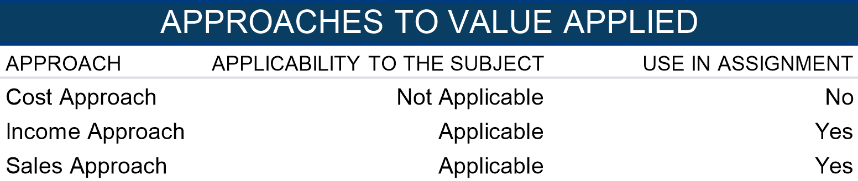

Income Approach

The Income Approach is based on the premise that properties are purchased for their income producing potential. It considers both the annual return on the invested capital and the return of the invested capital. The two fundamental methods of this valuation technique include Discounted Cash Flow and Direct Capitalization. The Direct Capitalization method of the Income Approach is used in this analysis. This valuation technique best represents the decision-making process of an investor.

Direct Capitalization Method

The first step in direct capitalization is to estimate the durable rental income through analysis of the in-place or projected (proposed developments) leases and market rent terms. Next, reimbursements and other revenue are analyzed. Then, vacancy and operating expenses are estimated. Finally, the net operating income is capitalized at a supported rate. The implied value may be adjusted to account for non-stabilized conditions or required capital expenditures to reflect an as-is value.

Multi-Family Revenue Analysis

Multi-Family Subject Rent Roll

The following table summarizes the subjects in place unit mix and rental rates.

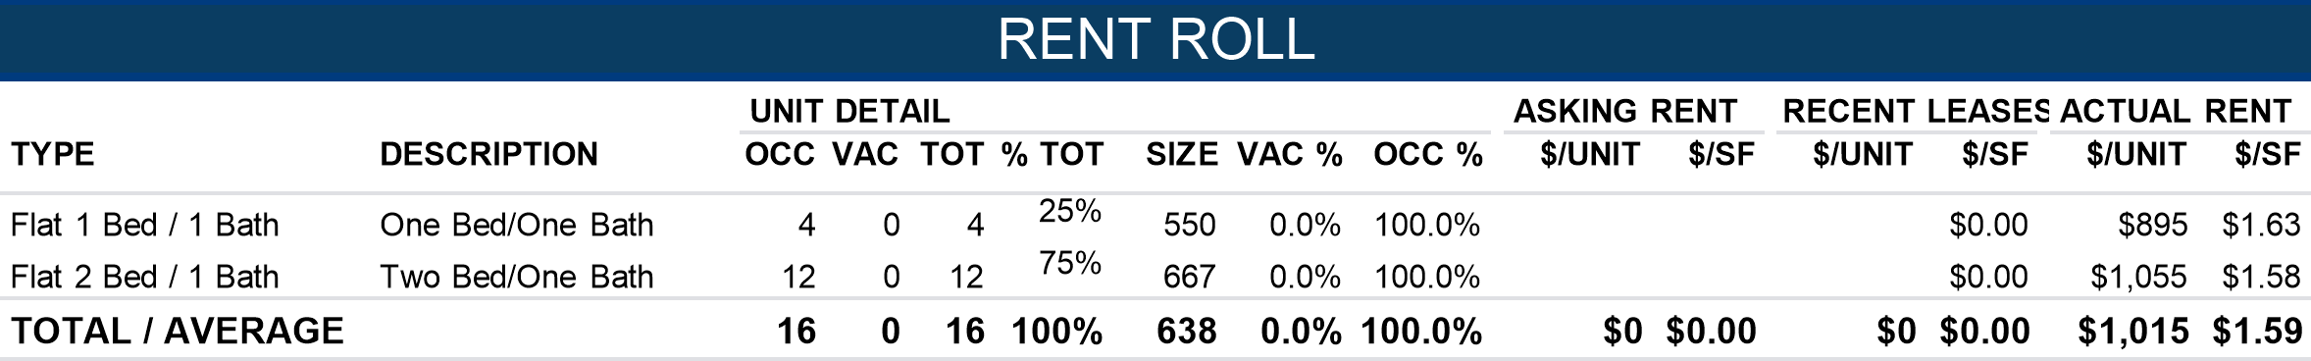

The majority of the subject tenant leases are on 12-month leases. In addition, security deposit fees for the property equal one month’s rent. The landlord pays for all utilities except electricity.

Multi-Family Market Rent Survey Analysis

This section examines comparable properties within the marketplace to estimate market rent for the subject. This allows for a comparison of the subject property’s contract to what is attainable in the current market.

Unit of Comparison

The analysis is conducted on a dollar per square foot, per month basis, reflecting market behavior. The total dollar per month per unit is also considered.

Selection of Comparables

A complete search of the area was conducted to find the most comparable properties in terms of location, tenancy, age, exposure, quality, and condition. The comparables in this analysis are the most reliable indicators of market rent for the subject available at the time of this appraisal.

Concessions

Currently landlords are not offering concessions.

Presentation

The following summarizes the comparables most similar to the subject property. The Survey Comparison Table, location map, photographs, and an analysis of the rent survey are presented on the following pages.

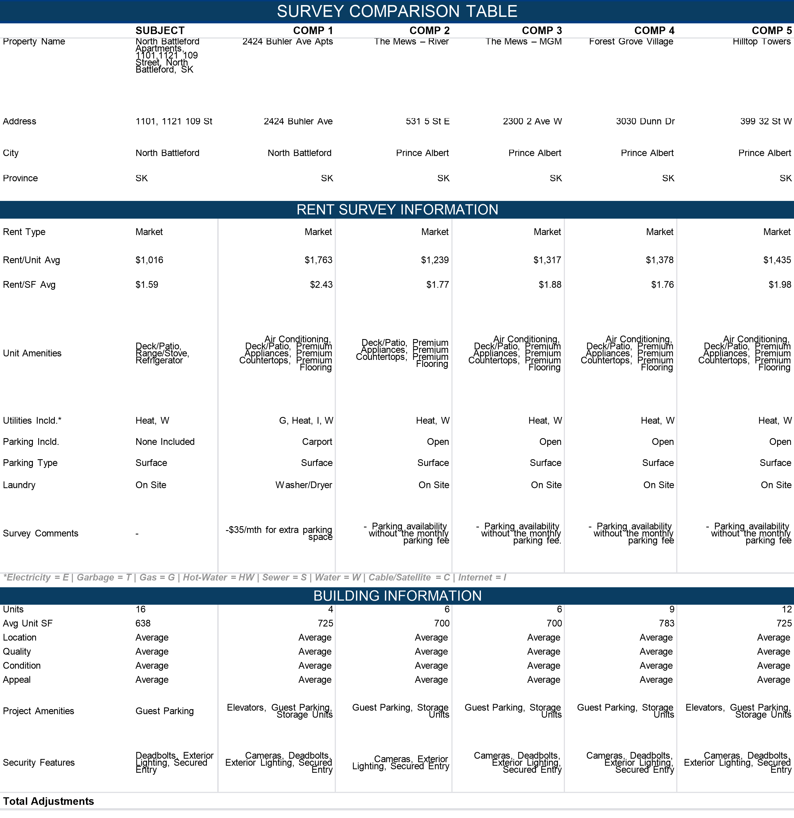

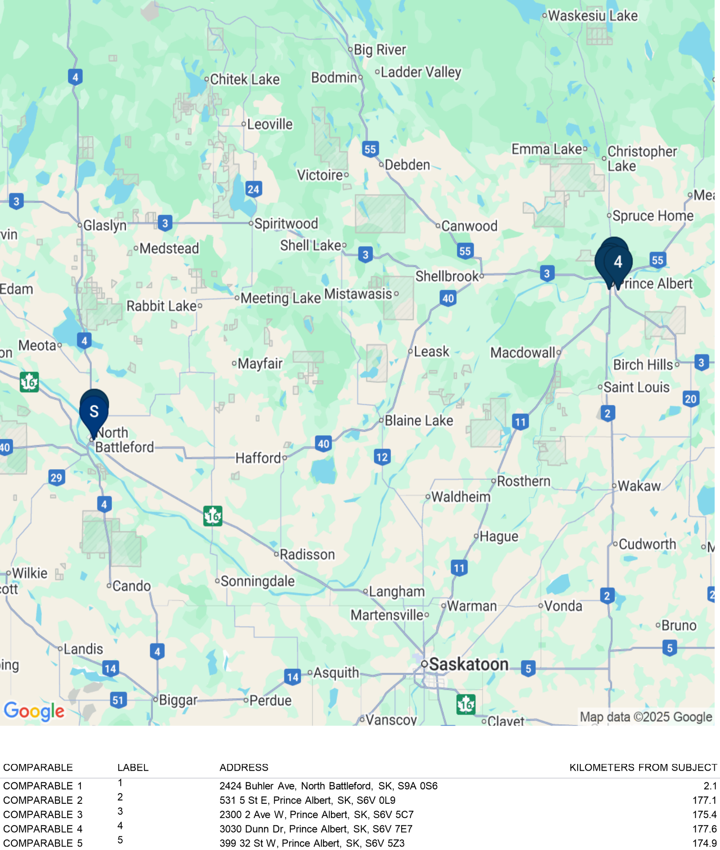

Conclusion Of Market Rent - Multi-Family

The following table summarizes the various indicators of market rent for each unit type and provides the market rent analysis and the conclusions for the subject property.

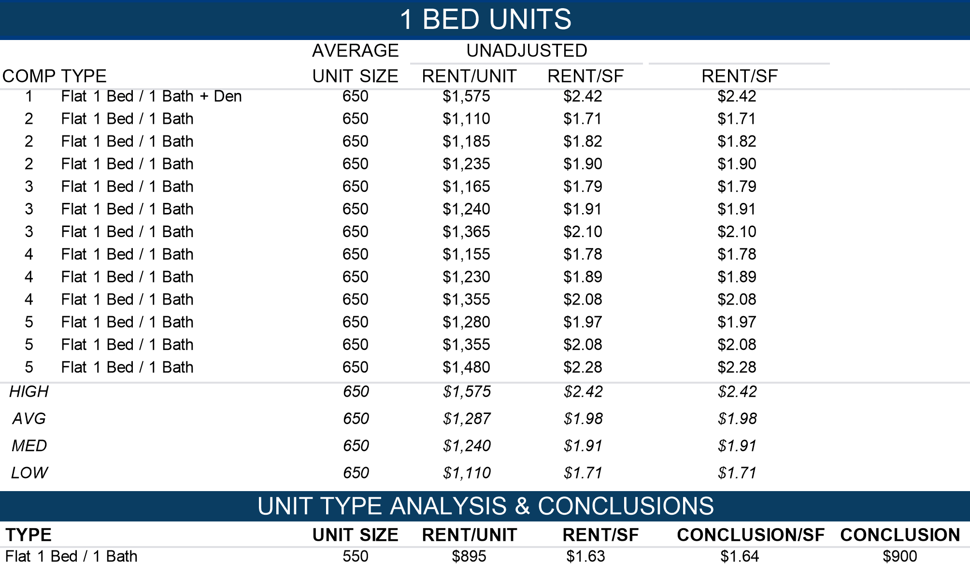

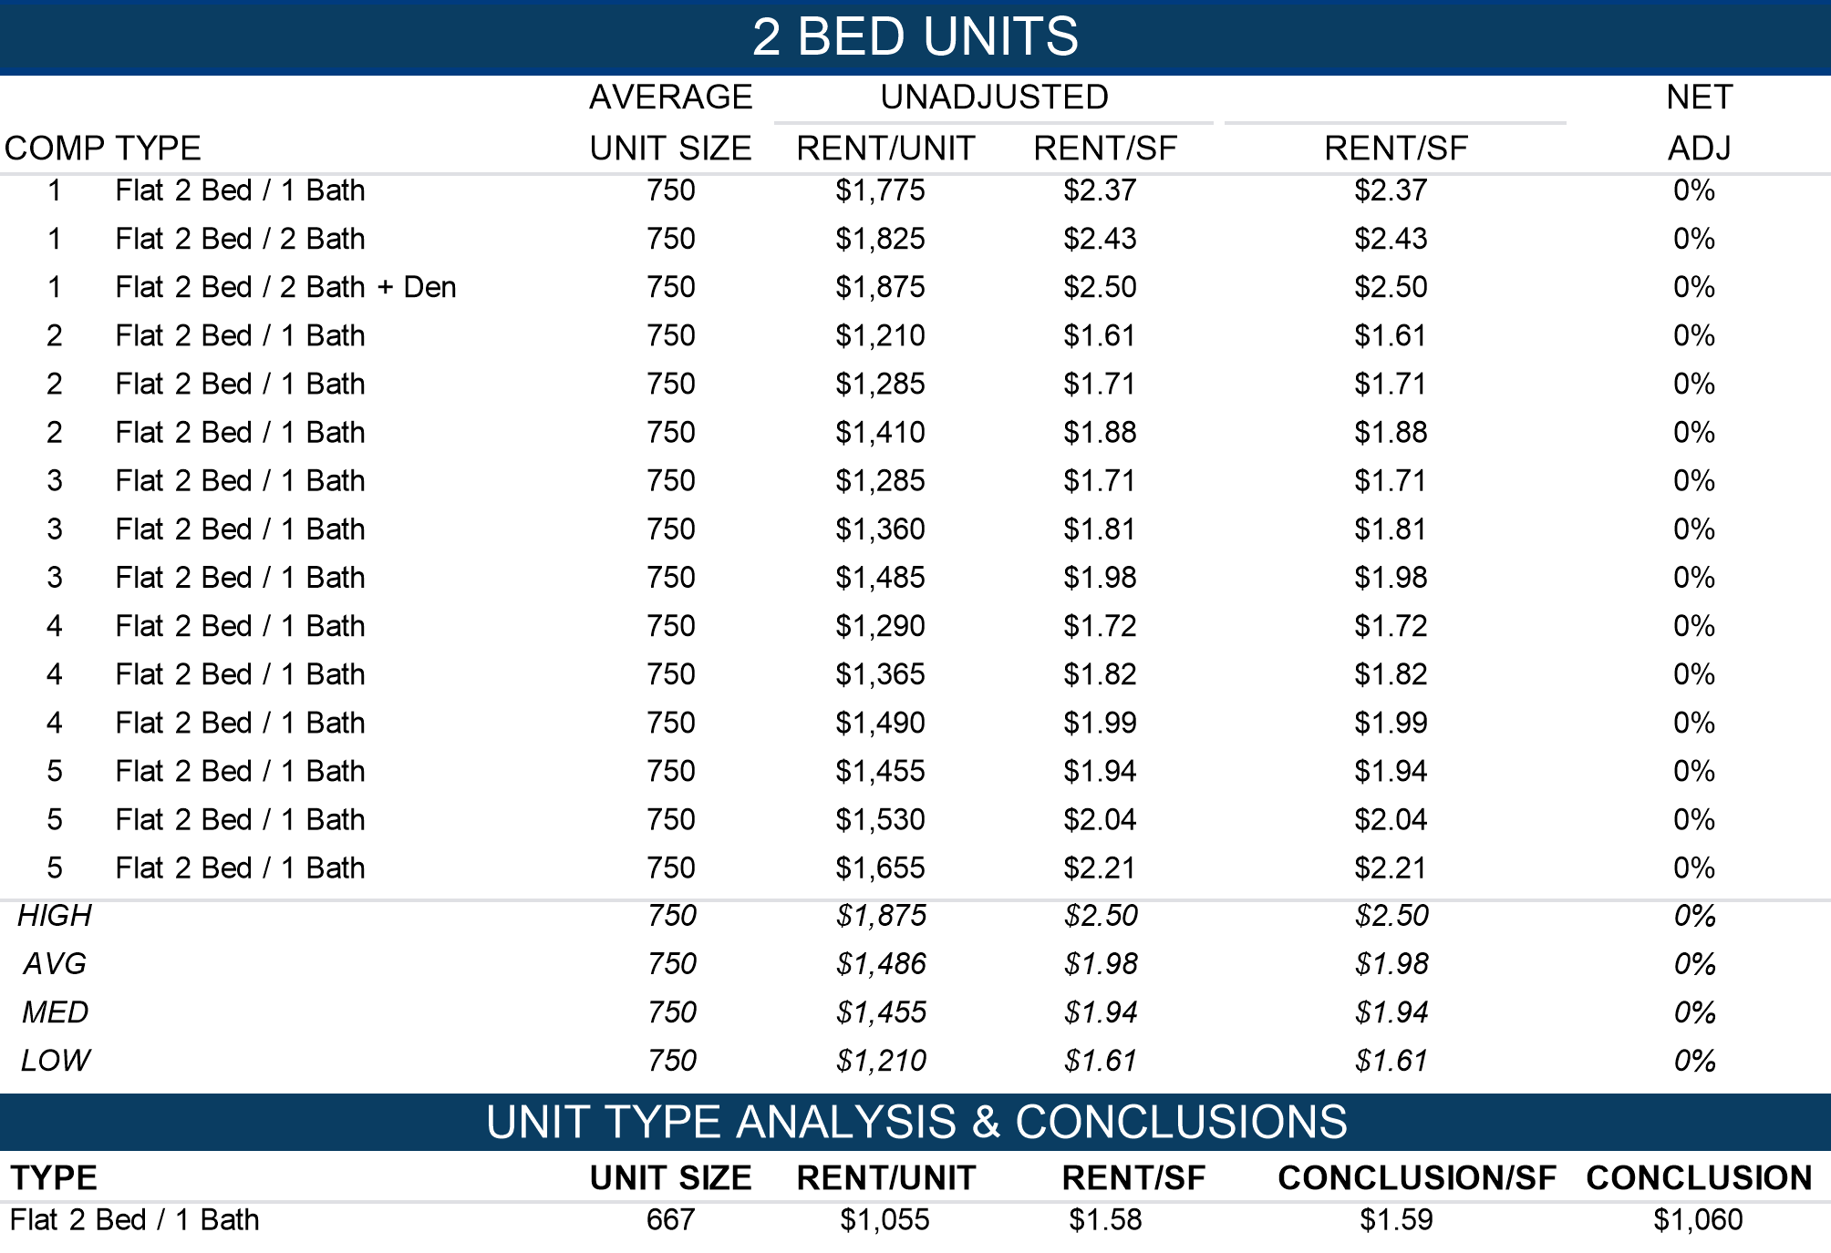

Unit Rent Discussion

The subject property, North Battleford Apartments at 1101, 1121 109 Street, is a 16-unit building of average quality and condition with heat and water included, surface parking, and on-site laundry.

A survey of five comparable buildings in North Battleford and Prince Albert shows 1-bedroom market rents ranging from $1,110–$1,575/month ($1.71–$2.42/SF). Most comparables include heat and water, with upgraded interiors and similar amenities.

Based on the comparables, the subject’s estimated market rent is:  
1 Bed / 1 Bath: $1,050/month ($1.62/SF)

This level is slightly below market averages, reflecting the property’s modest finishes and smaller scale, but it remains competitive within the local rental market.

Contract Versus Market Rent

Based on the previous conclusions, the subject’s average contract rent is 99.5% of market rents.

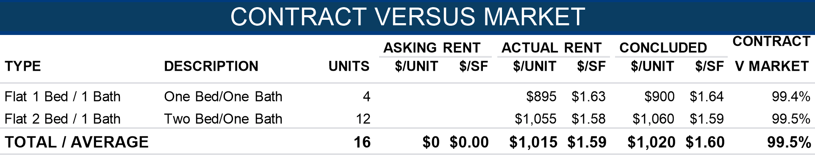

Total Rental Revenue - Multi-Family

The Total Rental Revenue for the Multi-Family component is summarized in the table below. The subject’s average contract rent is 99.5% of market rents. Market rents are applied in our analysis.

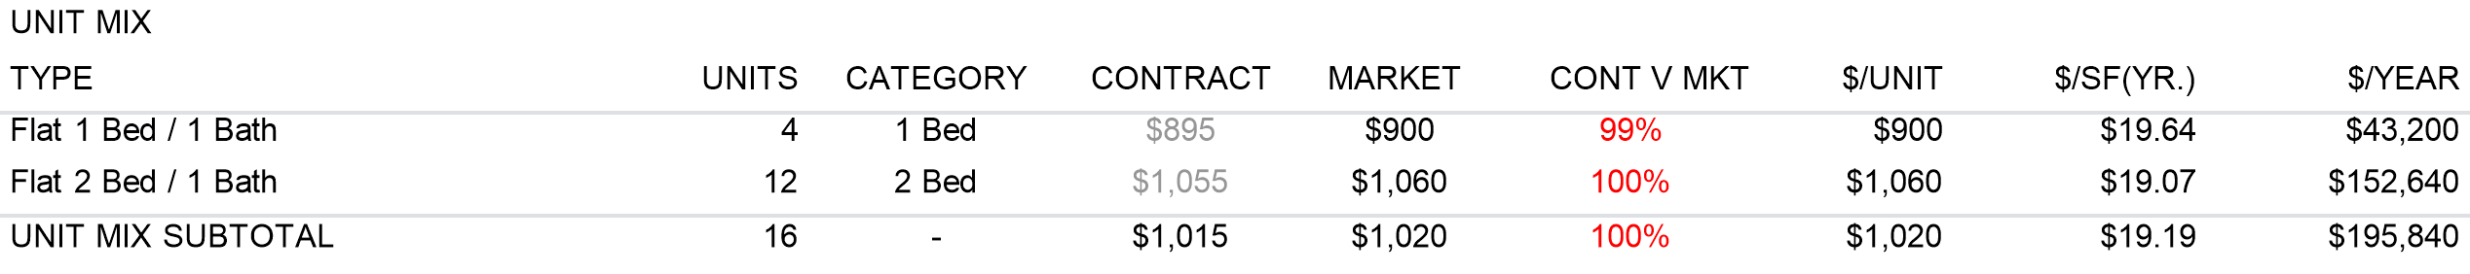

The following table summarizes the miscellaneous revenue projected for the subject property.

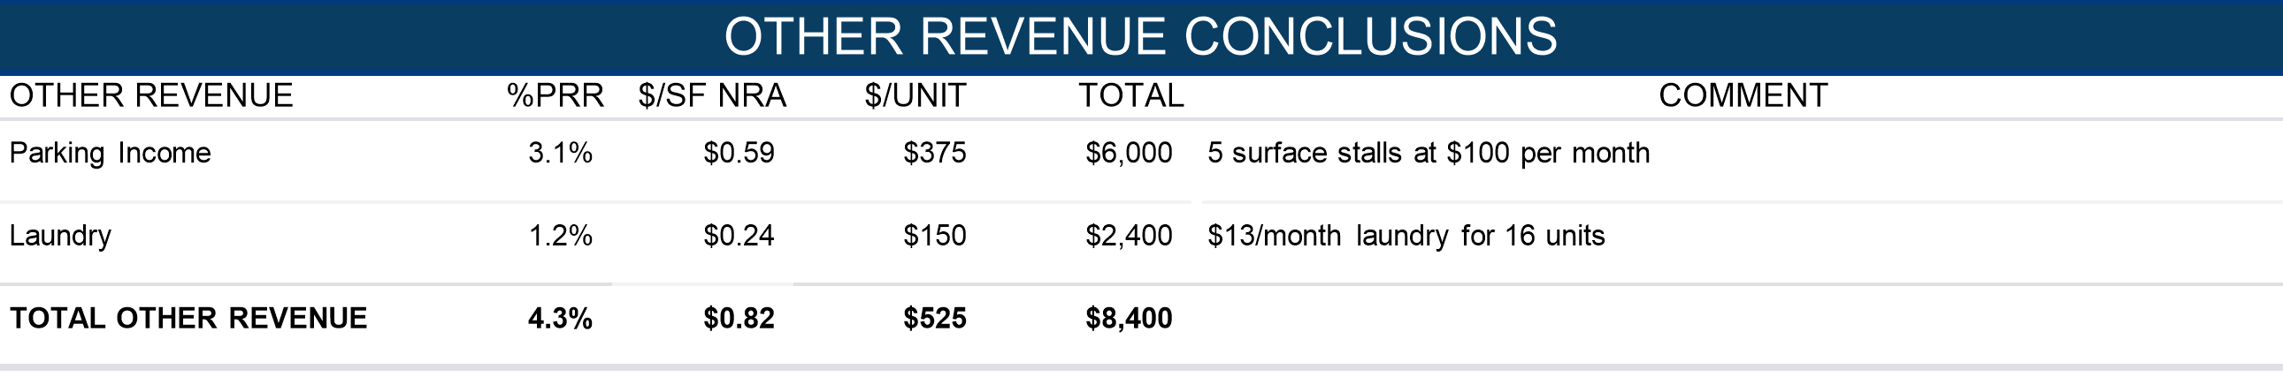

Potential Gross Revenue (PGR)

The potential gross revenue equals the total rental revenue plus reimbursement and miscellaneous revenue. The potential gross revenue of the subject is calculated by multiplying the sum of market rent of $12,765/Unit and $20.02 per square foot rent and reimbursements, if any, at $0 which is $0/Unit and -/SF by the net rentable area of 10,204 square feet, which indicates a PGR of $204,240.

Vacancy Allowance

This category accounts for the time period between occupants, as well as possible prolonged vacancies under slow market conditions. Market participants typically expect a vacancy of 2% to 5% of potential gross income for similar property types. This assignment reflects the probable vacancy during the economic life of the property and not necessarily the current or short-term vacancy. The findings of the Multi-Family Market Overview section support a typical vacancy allocation. As of the effective date, the subject is 100.0% occupied. Based on current and perceived long-term market conditions and the subject's anticipated tenancy over a typical holding period, a vacancy allowance of 3.8% is concluded.



Effective Gross Revenue (EGR)

Effective gross revenue equals the potential gross revenue less vacancy. The total effective gross revenue for the subject is $196,406 which is $12,275/Unit and $19.25/SF.

Operating Expenses

We have reviewed the owner’s historical operating expenses. As appropriate, the owner’s operating expenses are reclassified into standard categories and exclude items that do not reflect normal operating expenses for this type of property.

The reclassification is done for proper analysis against comparable data and industry benchmarks as appropriate. The subject’s historical operating expenses with our projections are shown in the following chart.

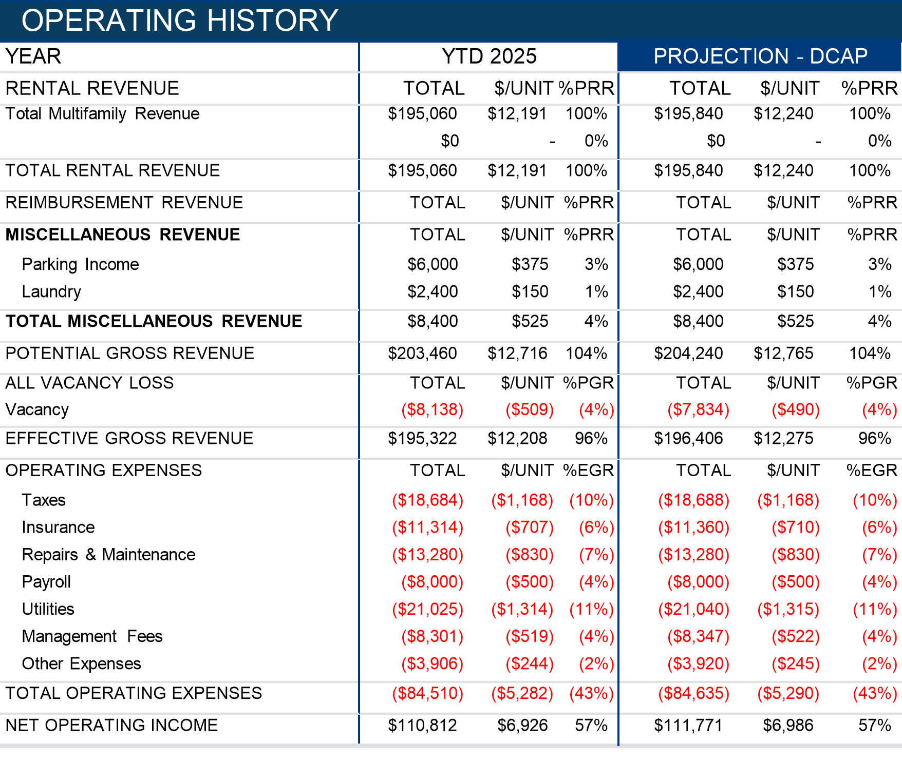

Expense Conclusions

The individual expense conclusions for the subject are summarized below.

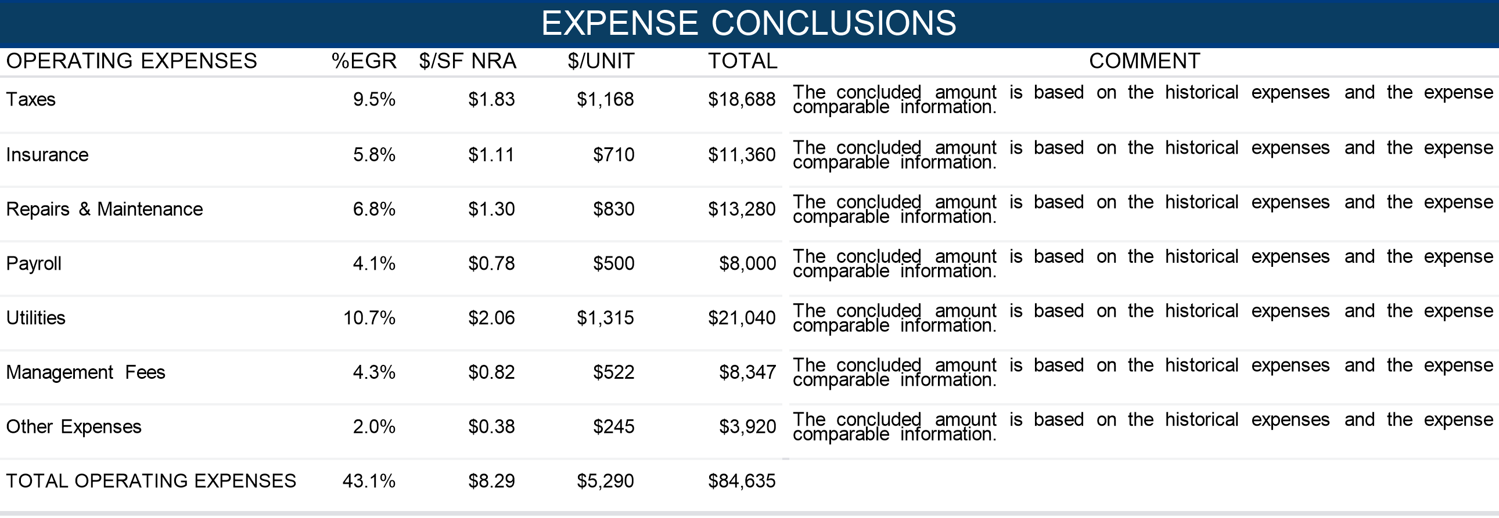

Net Operating Income (NOI)

The net operating income equals the effective gross income less the total expenses. The total net operating income for the subject is $111,771 which is $6,986/Unit and $10.95/SF.

Capitalization Rate Selection

To determine the appropriate capitalization rate for the subject property, consideration is given to:

* Alternative investment rates
* Investor activity and trends
* The property’s income, location, and physical characteristics
* Comparable sales and market activity

Alternative Investment Rates

The capitalization rate selected to value the subject property is expected to be higher than the current yield of approximately 3.2% on 10-year Government of Canada bonds. A risk premium of 75–300 basis points is typically applied to commercial and multifamily real estate, resulting in an implied capitalization rate in the range of 4.25%–6.25%. This spread reflects the illiquidity of real estate, management burden and overall (leasing, micro and macro market, physical, financing and regulatory) risk associated with real estate ownership compared to the risk free rate of government securities.

Investment Activity and Trends

The Multifamily Investment Indicator graph below highlights how multifamily yields track interest rate cycles. From 2015 to 2021, cap rates compressed into the mid-4% range as bond yields fell, with investors accepting narrower spreads in exchange for stable rental cash flows. Since 2022, rising bond yields have pushed cap rates back above 5.0%, restoring a healthier premium over government securities. Forecasts suggest modest re-compression as borrowing costs stabilize and spreads compress, though cap rates are expected to remain above 2021 lows given structurally higher rates. Boardwalk REIT’s reported fair market cap rate serves as a useful benchmark, providing an ancillary check on market yield expectations for multifamily assets.

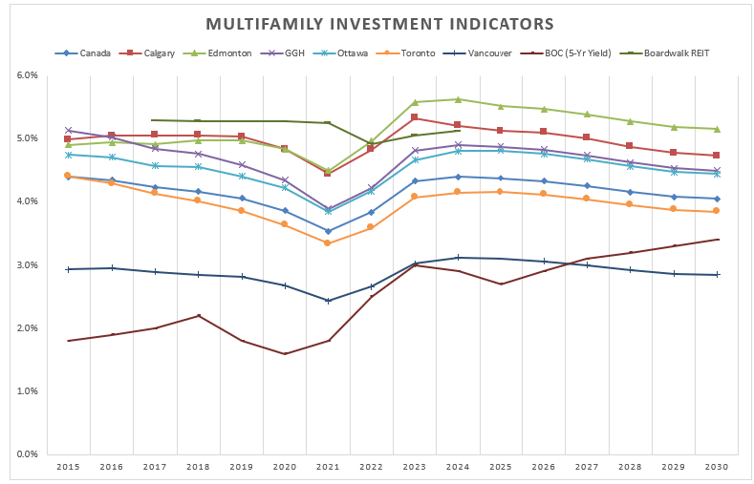

Capitalization Rate

In this section, a capitalization rate for the subject is developed based upon the comparable properties in the following table.

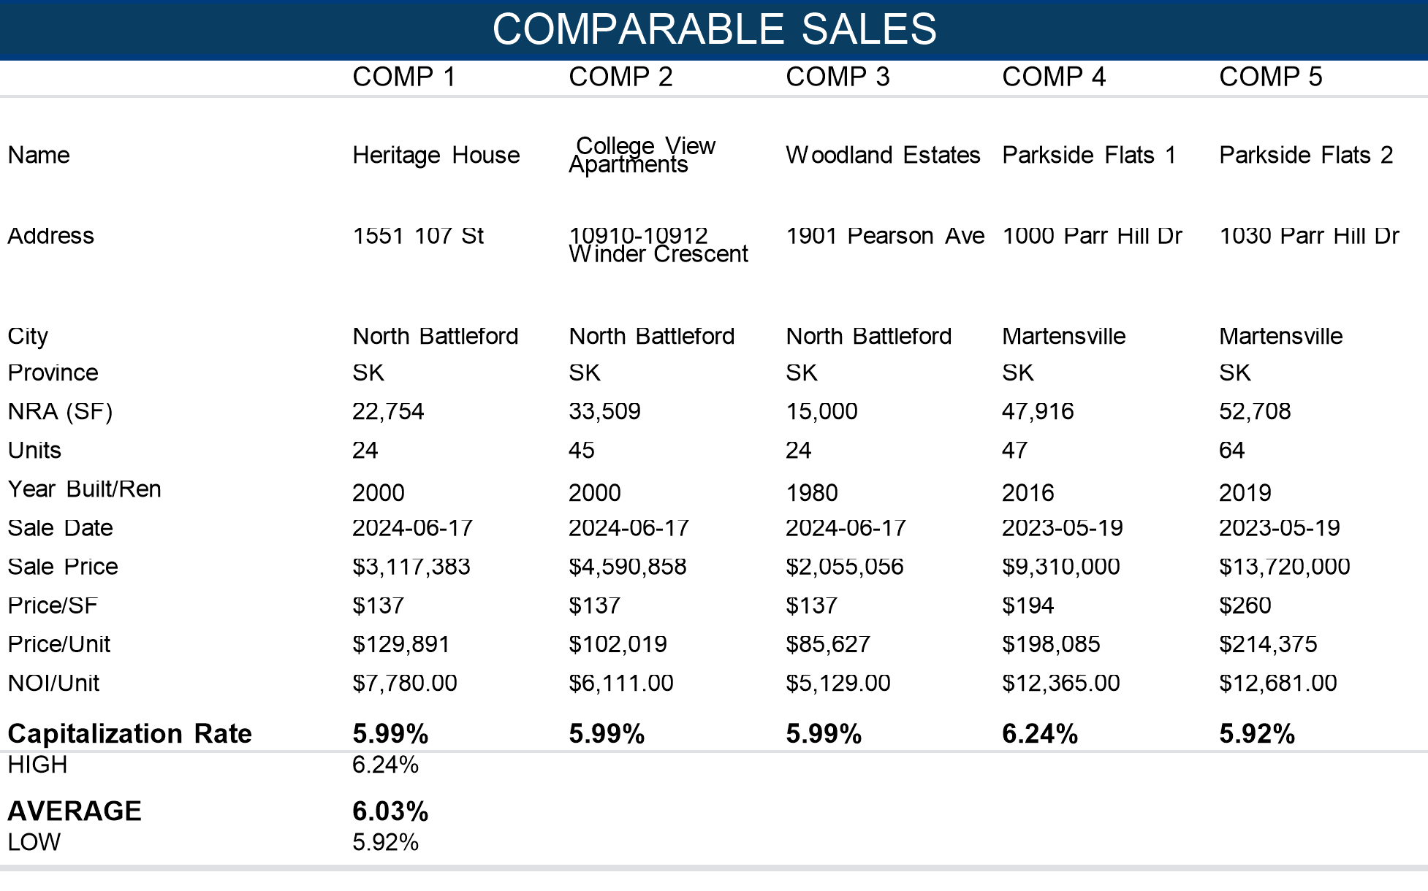

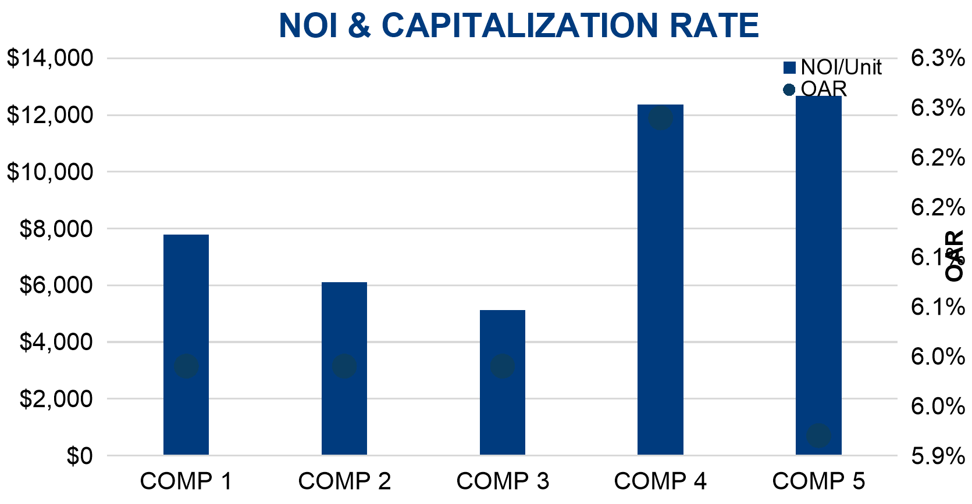

The comparable capitalization rates indicate a range from 5.92% to 6.24% with an average of 6.03%.

Capitalization Rate Analysis – Multifamily

Comparable sales were analyzed from both North Battleford and Martensville to reflect investor activity in tertiary Saskatchewan markets. The comparable properties indicate capitalization rates ranging from 5.92% to 6.24%, with the majority clustering near the 5.99% range.

The newer properties in Martensville (Parkside Flats 1 and 2) exhibit lower cap rates of 5.92%, consistent with higher-quality construction, modern finishes, and superior appeal. In contrast, the older assets located in North Battleford, such as Heritage House and College View Apartments, achieved cap rates closer to 5.99%–6.24%, reflecting higher risk premiums associated with tertiary markets, older improvements, and smaller population bases.

Given the subject’s age (circa 1970), average quality, and its location within North Battleford, a smaller, tertiary market with limited liquidity, an upward adjustment toward the higher end of the observed range is appropriate. The subject’s stable occupancy and average condition support investor confidence, though risk perception remains elevated relative to newer urban comparables.

Based on the foregoing analysis, an appropriate capitalization rate for the subject property is concluded at approximately 6.25%, reflecting market expectations for well-maintained, stabilized multifamily assets within tertiary Saskatchewan markets.

Capitalization Rate Conclusion

Based on these indicators and the subject’s characteristics, average location, vintage, and limited amenity offering, a cap rate at the higher end of the range is considered appropriate for valuing the subject on an as stabilized basis. This aligns with recent market activity for similar assets in comparable locations.

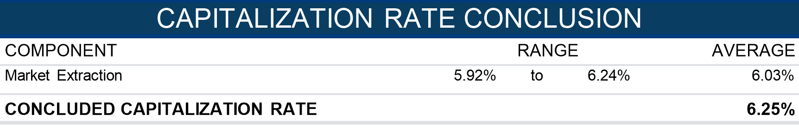

Direct Capitalization Conclusion

The table below summarizes the Direct Capitalization Method and its value conclusion.

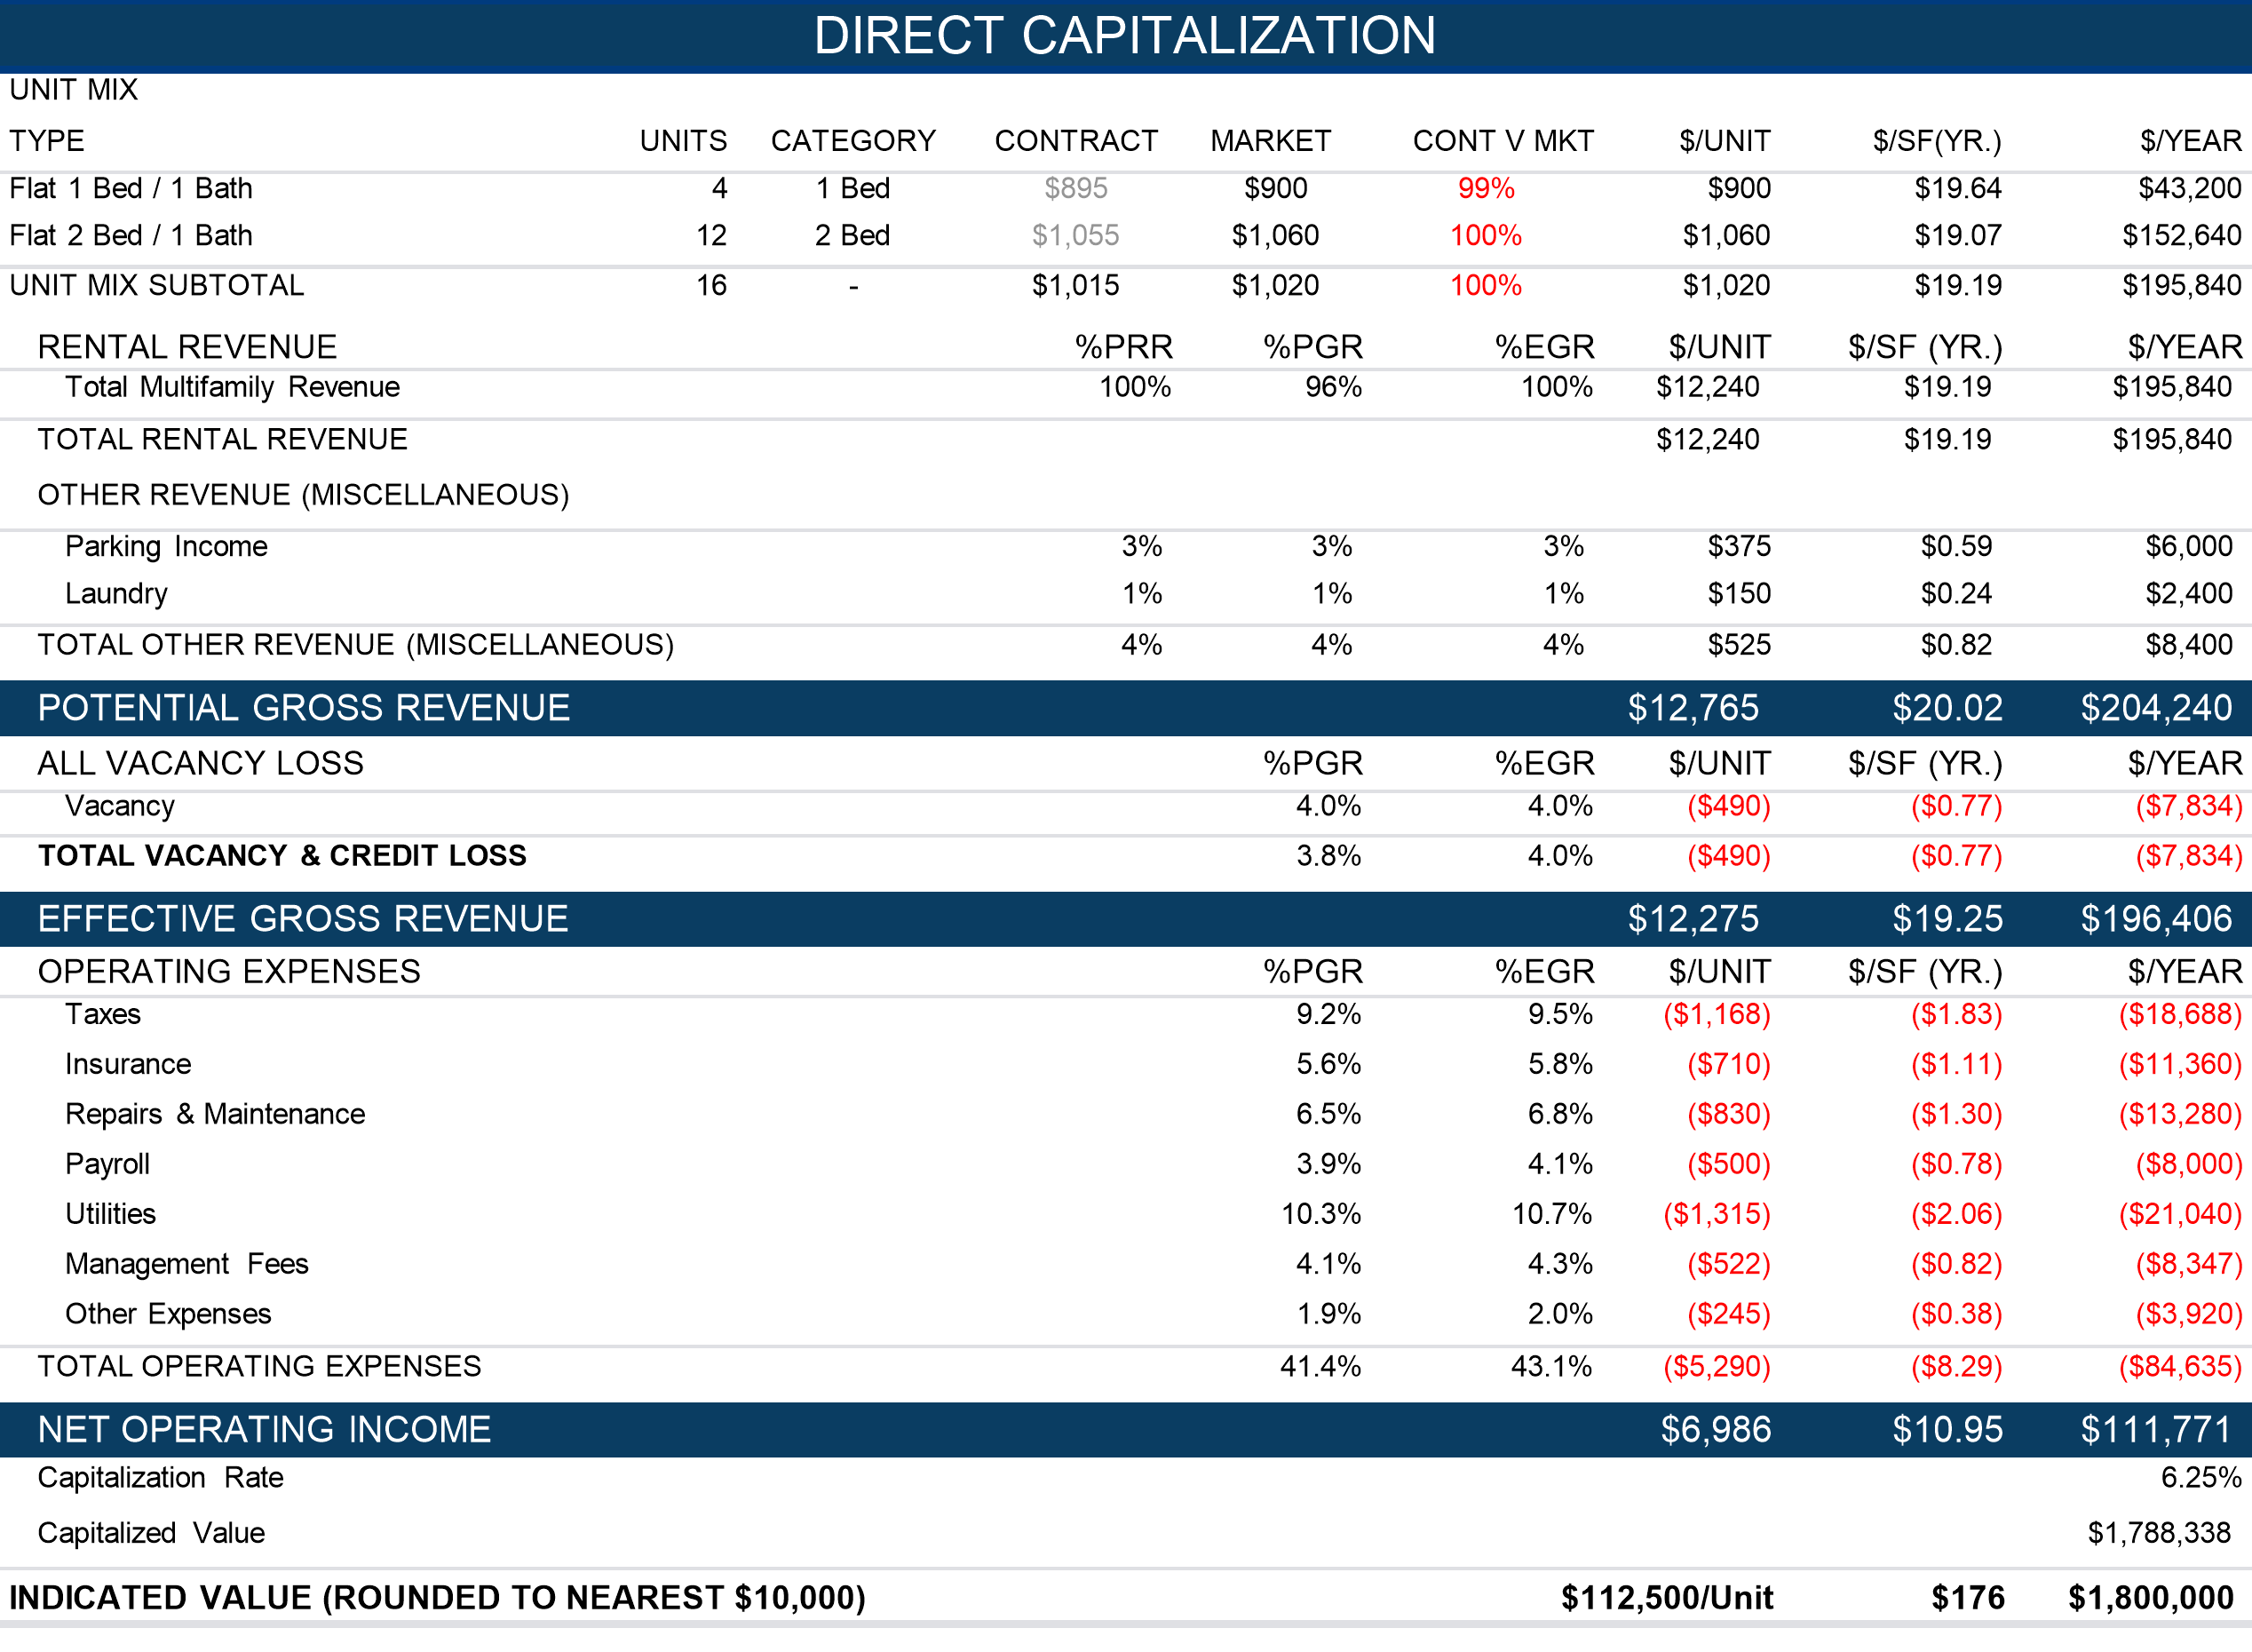

Income Approach Conclusion

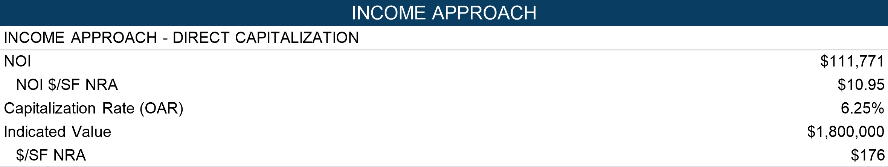

Given that the subject is a multitenant asset with short term it is generally understood that the direct capitalization method is preferred, making the discounted cash flow (DCF) method less meaningful. For this reason, we have completed only the direct capitalization method.

Direct Comparison Approach: Multifamily

Introduction

In the Sales Comparison Approach, the value of a property is estimated by comparing it with similar, recently sold properties in the surrounding or competing areas. Inherent in this approach is the principle of substitution, which holds that when a property is replaceable in the market, its value tends to be set by the cost of buying an equally desirable property, assuming that no costly delay occurs in making the substitution.

Comparable Selection

Through the analysis of sales of verified arm’s-length transactions, market value and price trends are identified. The sales utilized are comparable to the subject in physical, functional, and economic characteristics.

Comparable sales are presented, which were selected due to their similarity in physical, locational, and qualitative attributes. They represent the most recent and relevant comparable sale available for this analysis. Emphasis was given to the subject’s location and similarly positioned properties.

Unit of Comparison

The most relevant unit of comparison is the price per Unit. This best reflects the unit of comparison used by buyers and sellers in this market for the subject property type.

Adjustments

Adjustments to the comparable sales were considered and made when warranted for property rights, financing terms, conditions of sale, expenditures after sale and market conditions.

1. **Property Rights -** All the sales comparables were fee simple sales reflecting the property rights appraised herein per the agreed upon scope of work.
2. **Financing -** The sales all reflected typical cash equivalent, lender-financed transactions and no adjustments were required for financing terms.
3. **Sale Conditions -** None of the comparables required a condition of sale adjustment, as all were confirmed to be arm’s length transactions.
4. **Expenditures After Sale -** Expenses that the buyer incurs after purchase (deferred maintenance, HVAC repairs, etc.). No adjustments are warranted based on review of the sales.
5. **Market Conditions (Time) -** Based on the analysis performed, which includes research and interpretation of value trends of the comparables presented herein, a market conditions adjustment of 0% is applied on an Annual basis reflecting the relatively consistent appreciation that occurred between the oldest comparable sale date up through the effective valuation date.

Quantitative Adjustment Process

In this method, we have compared the sales to the subject primarily along economic lines rather than on physical characteristics.  Economic measures such as the relationship of sales price to net operating income are inclusive of all the physical and economic attributes of a property. It should be stressed that the adjustments are subjective in nature and are meant to illustrate the logic in deriving a value opinion for the subject property by the Sales Comparison Approach.

Presentation

The subject and comparable property attributes are presented on the following Improved Sales Comparison Table, location map and photographs. This is followed by analysis of the subject and comparable sales and the value conclusion indicated using the Sales Comparison Approach.

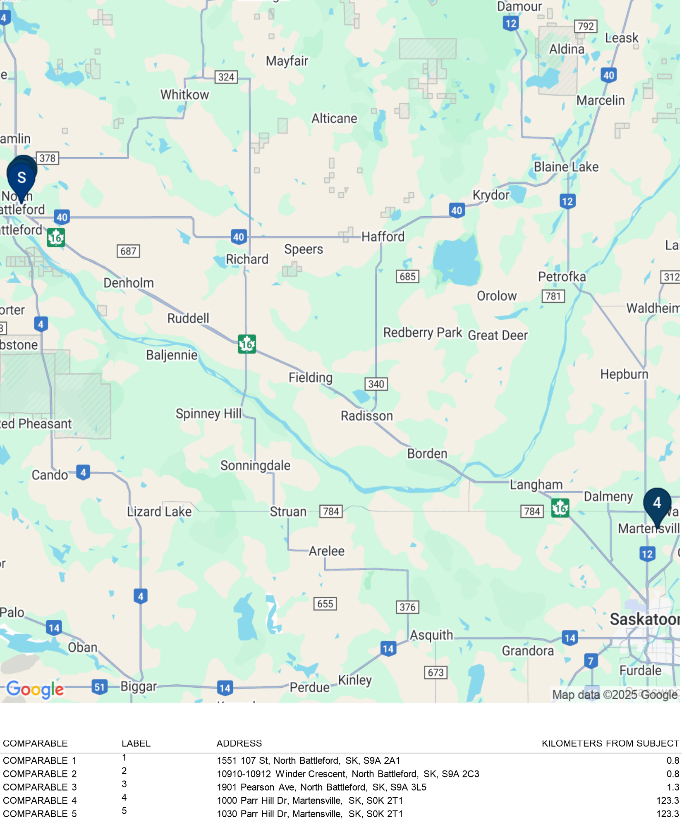

Sales Summary Sheets

|  |  |  |  |  |  |  |  |  |  |  |  |  |  |  |  |  |  |  |  |  |  |  |  |  |  |  |  |  |  |  |  |  |  |  |  |  |  |  |  |  |  |  |  |  |  |  |  |  |  |  |  |  |  |  |  |  |  |  |  |  |  |  |  |  |  |  |  |  |  |  |  |  |  |  |  |  |  |  |  |  |  |  |  |  |  |  |  |  |  |  |  |  |  |  |  |  |  |  |  |  |  |  |  |  |
| --- | --- | --- | --- | --- | --- | --- | --- | --- | --- | --- | --- | --- | --- | --- | --- | --- | --- | --- | --- | --- | --- | --- | --- | --- | --- | --- | --- | --- | --- | --- | --- | --- | --- | --- | --- | --- | --- | --- | --- | --- | --- | --- | --- | --- | --- | --- | --- | --- | --- | --- | --- | --- | --- | --- | --- | --- | --- | --- | --- | --- | --- | --- | --- | --- | --- | --- | --- | --- | --- | --- | --- | --- | --- | --- | --- | --- | --- | --- | --- | --- | --- | --- | --- | --- | --- | --- | --- | --- | --- | --- | --- | --- | --- | --- | --- | --- | --- | --- | --- | --- | --- | --- | --- | --- |
| Heritage House  Comparable 1   |  |  |  |  | | --- | --- | --- | --- | | Sale Information | | | | | Buyer | Epiphany Group | | | | Seller | Macro Properties Toronto | | | | Sale Date | 2024-06-17 | | | | Transaction Status | Closed | | | | Sale Price | $3,117,383 | $129,891 | /Unit | | Analysis Price | $3,117,383 | $129,891 | /Unit | | Rights Transferred | Fee Simple | | | | Financing | Cash to Seller | | | | Conditions of Sale | Arm's Length | | |  |  |  |  |  | | --- | --- | --- | --- | | Income Analysis | | | | | Occupancy | 100.0% | | | | Net Operating Income | $186,731.24 | $7,780.47 | /Unit | | Cap Rate | 5.99% | | |  |  |  | | --- | --- | | Property | | | Type | Multi-Family, Walk-Up | | Rent Type | Market | | Gross Building Area (GBA) | 22,754 SF | | Net Rentable Area (NRA) | 22,754 SF | | Units | 24 | | Buildings | 1 Building, 3 Floors | | Year Built | 2000 | | Land Area | 0.5 Acres (21,780 SF) | | Corner | No | | Project Amenities | Guest Parking | | Security Features | Deadbolts, Exterior Lighting, Secured Entry | | Laundry | On Site | | Unit Amenities | Air Conditioning, Range/Stove, Refrigerator | | Parking Type | Surface | | Utilities | Full Municipal Services |  |  |  |  |  | | --- | --- | --- | --- | | Unit Mix | | Units | Avg. Size | | Flat | 1 Bed / 1 Bath | 24 | 0 SF | | |  | | --- | |  |  |  |  | | --- | --- | | 1551 107 St North Battleford, SK S9A 2A1 |  | | County North Battleford | | Submarket Saskatchewan Area |  |  | | --- | | Remarks | | Macro Properties Toronto sold this 143-unit portfolio to Epiphany Group for $14,000,000 or $97,902.09 per unit. The buyer was drawn to purchasing these properties to diversity and strengthen their investment portfolio. The net operating income in 2024 was reported to be $838,909, yielding a 5.99% cap rate. | |

|  |  |  |  |  |  |  |  |  |  |  |  |  |  |  |  |  |  |  |  |  |  |  |  |  |  |  |  |  |  |  |  |  |  |  |  |  |  |  |  |  |  |  |  |  |  |  |  |  |  |  |  |  |  |  |  |  |  |  |  |  |  |  |  |  |  |  |  |  |  |  |  |  |  |  |  |  |  |  |  |  |  |  |  |  |  |  |  |  |  |  |  |  |  |  |  |  |  |  |  |  |  |  |  |  |
| --- | --- | --- | --- | --- | --- | --- | --- | --- | --- | --- | --- | --- | --- | --- | --- | --- | --- | --- | --- | --- | --- | --- | --- | --- | --- | --- | --- | --- | --- | --- | --- | --- | --- | --- | --- | --- | --- | --- | --- | --- | --- | --- | --- | --- | --- | --- | --- | --- | --- | --- | --- | --- | --- | --- | --- | --- | --- | --- | --- | --- | --- | --- | --- | --- | --- | --- | --- | --- | --- | --- | --- | --- | --- | --- | --- | --- | --- | --- | --- | --- | --- | --- | --- | --- | --- | --- | --- | --- | --- | --- | --- | --- | --- | --- | --- | --- | --- | --- | --- | --- | --- | --- | --- | --- |
| College View Apartments  Comparable 2   |  |  |  |  | | --- | --- | --- | --- | | Sale Information | | | | | Buyer | Epiphany Group | | | | Seller | Macro Properties Toronto | | | | Sale Date | 2024-06-17 | | | | Transaction Status | Closed | | | | Sale Price | $4,590,858 | $102,019 | /Unit | | Analysis Price | $4,590,858 | $102,019 | /Unit | | Rights Transferred | Fee Simple | | | | Financing | Cash To Seller | | | | Conditions of Sale | Arm's Length | | |  |  |  |  |  | | --- | --- | --- | --- | | Income Analysis | | | | | Occupancy | 100.0% | | | | Net Operating Income | $274,992.39 | $6,110.94 | /Unit | | Cap Rate | 5.99% | | |  |  |  | | --- | --- | | Property | | | Type | Multi-Family, Walk-Up | | Rent Type | Market | | Gross Building Area (GBA) | 33,509 SF | | Net Rentable Area (NRA) | 33,509 SF | | Units | 45 | | Buildings | 2 Buildings, 3 Floors | | Year Built | 2000 | | Land Area | 0.5 Acres (21,780 SF) | | Zoning | R1 | | Corner | No | | Project Amenities | No Amenities | | Laundry | On Site | | Unit Amenities | Range/Stove, Refrigerator | | Parking Type | Surface | | Utilities | Full Municipal Services |  |  |  |  |  | | --- | --- | --- | --- | | Unit Mix | | Units | Avg. Size | | Flat | 1 Bed / 1 Bath | 45 | 0 SF | | |  | | --- | |  |  |  |  | | --- | --- | | 10910-10912 Winder Crescent North Battleford, SK S9A 2C3 |  | | County North Battleford | | Submarket Saskatchewan Area |  |  | | --- | | Remarks | | Macro Properties Toronto sold this 143-unit portfolio to Epiphany Group for $14,000,000 or $97,902.09 per unit. The buyer was drawn to purchasing these properties to diversify and strengthen their investment portfolio. The net operating income in 2024 was reported to be $838,909, yielding a 5.99% cap rate. | |

|  |  |  |  |  |  |  |  |  |  |  |  |  |  |  |  |  |  |  |  |  |  |  |  |  |  |  |  |  |  |  |  |  |  |  |  |  |  |  |  |  |  |  |  |  |  |  |  |  |  |  |  |  |  |  |  |  |  |  |  |  |  |  |  |  |  |  |  |  |  |  |  |  |  |  |  |  |  |  |  |  |  |  |  |  |  |  |  |  |  |  |  |  |  |  |  |  |  |  |  |  |  |  |  |  |
| --- | --- | --- | --- | --- | --- | --- | --- | --- | --- | --- | --- | --- | --- | --- | --- | --- | --- | --- | --- | --- | --- | --- | --- | --- | --- | --- | --- | --- | --- | --- | --- | --- | --- | --- | --- | --- | --- | --- | --- | --- | --- | --- | --- | --- | --- | --- | --- | --- | --- | --- | --- | --- | --- | --- | --- | --- | --- | --- | --- | --- | --- | --- | --- | --- | --- | --- | --- | --- | --- | --- | --- | --- | --- | --- | --- | --- | --- | --- | --- | --- | --- | --- | --- | --- | --- | --- | --- | --- | --- | --- | --- | --- | --- | --- | --- | --- | --- | --- | --- | --- | --- | --- | --- | --- |
| Woodland Estates  Comparable 3   |  |  |  |  | | --- | --- | --- | --- | | Sale Information | | | | | Buyer | Epiphany Group | | | | Seller | Macro Properties Toronto | | | | Sale Date | 2024-06-17 | | | | Transaction Status | Closed | | | | Sale Price | $2,055,056 | $85,627 | /Unit | | Analysis Price | $2,055,056 | $85,627 | /Unit | | Rights Transferred | Fee Simple | | | | Financing | Cash to Seller | | | | Conditions of Sale | Arm's Length | | |  |  |  |  |  | | --- | --- | --- | --- | | Income Analysis | | | | | Occupancy | 100.0% | | | | Net Operating Income | $123,097.85 | $5,129.08 | /Unit | | Cap Rate | 5.99% | | |  |  |  | | --- | --- | | Property | | | Type | Multi-Family, Walk-Up | | Rent Type | Market | | Gross Building Area (GBA) | 15,000 SF | | Net Rentable Area (NRA) | 15,000 SF | | Units | 24 | | Buildings | 2 Buildings, 3 Floors | | Year Built | 1980 | | Land Area | 1.1932 Acres (51,977 SF) | | Corner | No | | Project Amenities | Guest Parking | | Security Features | Deadbolts, Exterior Lighting, Secured Entry | | Laundry | On Site | | Unit Amenities | Air Conditioning, Range/Stove, Refrigerator | | Parking Type | Surface | | Utilities | Full Municipal Services |  |  |  |  |  | | --- | --- | --- | --- | | Unit Mix | | Units | Avg. Size | | Flat | 1 Bed / 1 Bath | 24 | 0 SF | | |  | | --- | |  |  |  |  | | --- | --- | | 1901 Pearson Ave North Battleford, SK S9A 3L5 |  | | County North Battleford | | Submarket Saskatchewan Area |  |  | | --- | | Remarks | | Macro Properties Toronto sold this 143-unit portfolio to Epiphany Group for $14,000,000 or $97,902.09 per unit. The buyer was drawn to purchasing these properties to diversity and strengthen their investment portfolio. The net operating income in 2024 was reported to be $838,909, yielding a 5.99% cap rate. | |

|  |  |  |  |  |  |  |  |  |  |  |  |  |  |  |  |  |  |  |  |  |  |  |  |  |  |  |  |  |  |  |  |  |  |  |  |  |  |  |  |  |  |  |  |  |  |  |  |  |  |  |  |  |  |  |  |  |  |  |  |  |  |  |  |  |  |  |  |  |  |  |  |  |  |  |  |  |  |  |  |  |  |  |  |  |  |  |  |  |  |  |  |  |  |  |  |  |  |  |  |  |  |  |  |  |  |  |  |  |  |  |  |  |  |  |  |  |  |
| --- | --- | --- | --- | --- | --- | --- | --- | --- | --- | --- | --- | --- | --- | --- | --- | --- | --- | --- | --- | --- | --- | --- | --- | --- | --- | --- | --- | --- | --- | --- | --- | --- | --- | --- | --- | --- | --- | --- | --- | --- | --- | --- | --- | --- | --- | --- | --- | --- | --- | --- | --- | --- | --- | --- | --- | --- | --- | --- | --- | --- | --- | --- | --- | --- | --- | --- | --- | --- | --- | --- | --- | --- | --- | --- | --- | --- | --- | --- | --- | --- | --- | --- | --- | --- | --- | --- | --- | --- | --- | --- | --- | --- | --- | --- | --- | --- | --- | --- | --- | --- | --- | --- | --- | --- | --- | --- | --- | --- | --- | --- | --- | --- | --- | --- | --- | --- | --- |
| Parkside Flats 1  Comparable 4   |  |  |  |  | | --- | --- | --- | --- | | Sale Information | | | | | Buyer | 600342 Ontario Inc. | | | | Seller | 101300036 Saskatchewan Ltd. | | | | Sale Date | 2023-05-19 | | | | Transaction Status | Closed | | | | Sale Price | $9,310,000 | $198,085 | /Unit | | Analysis Price | $9,310,000 | $198,085 | /Unit | | Recording Number | 156498441 | | | | Rights Transferred | Fee Simple | | | | Financing | Cash to Seller | | | | Conditions of Sale | Arm's Length | | |  |  |  |  |  | | --- | --- | --- | --- | | Income Analysis | | | | | Occupancy | 100.0% | | | | Expenses | ($235,062) | ($5,001.32) | /Unit | | Net Operating Income | $581,178 | $12,365.49 | /Unit | | Cap Rate | 6.24% | | |  |  |  | | --- | --- | | Property | | | Type | Multi-Family, Low-Rise | | Rent Type | Market | | Gross Building Area (GBA) | 47,916 SF | | Net Rentable Area (NRA) | 47,916 SF | | Units | 47 | | Buildings | 1 Building | | Year Built | 2016 | | Land Area | 1.1 Acres (47,916 SF) | | Zoning | R3 | | Corner | Yes | | Project Amenities | Elevators, Guest Parking, Storage Units | | Security Features | Cameras, Deadbolts, Exterior Lighting, Secured Entry | | Laundry | Washer/Dryer | | Unit Amenities | Air Conditioning, Deck/Patio, Premium Appliances, Premium Countertops, Premium Flooring, Walk-in Closets | | Parking Type | Surface | | Utilities | Full Municipal Services |  |  |  |  |  | | --- | --- | --- | --- | | Unit Mix | | Units | Avg. Size | | Flat | 1 Bed / 0 Bath | 11 | 0 SF | | Flat | 2 Bed / 0 Bath | 36 | 0 SF | | |  | | --- | |  |  |  |  | | --- | --- | | 1000 Parr Hill Dr Martensville, SK S0K 2T1 |  | | County Corman Park No. 344 |  |  | | --- | | Remarks | | Parkside Flats, a 47-unit multifamily property located at 1000 Parr Hill Drive in Martensville, Saskatchewan, sold on May 19, 2023, for $9,310,000, reflecting a price per unit of $198,085. The property was purchased by 600342 Ontario Inc. from 101300036 Saskatchewan Ltd. in an arm’s-length, cash-to-seller transaction. Constructed in 2016, Parkside Flats is a wood-frame apartment building featuring 11 one-bedroom units and 36 two-bedroom units. Each suite offers modern finishes, in-suite laundry, and access to surface parking. Parkside Flats generated an estimated net operating income of $581,178, resulting in a capitalization rate of 6.24%, The transaction formed part of a larger portfolio acquisition that included two additional apartment buildings. | |

|  |  |  |  |  |  |  |  |  |  |  |  |  |  |  |  |  |  |  |  |  |  |  |  |  |  |  |  |  |  |  |  |  |  |  |  |  |  |  |  |  |  |  |  |  |  |  |  |  |  |  |  |  |  |  |  |  |  |  |  |  |  |  |  |  |  |  |  |  |  |  |  |  |  |  |  |  |  |  |  |  |  |  |  |  |  |  |  |  |  |  |  |  |  |  |  |  |  |  |  |  |  |  |  |  |  |  |  |  |  |  |  |  |  |  |  |  |  |  |  |  |  |
| --- | --- | --- | --- | --- | --- | --- | --- | --- | --- | --- | --- | --- | --- | --- | --- | --- | --- | --- | --- | --- | --- | --- | --- | --- | --- | --- | --- | --- | --- | --- | --- | --- | --- | --- | --- | --- | --- | --- | --- | --- | --- | --- | --- | --- | --- | --- | --- | --- | --- | --- | --- | --- | --- | --- | --- | --- | --- | --- | --- | --- | --- | --- | --- | --- | --- | --- | --- | --- | --- | --- | --- | --- | --- | --- | --- | --- | --- | --- | --- | --- | --- | --- | --- | --- | --- | --- | --- | --- | --- | --- | --- | --- | --- | --- | --- | --- | --- | --- | --- | --- | --- | --- | --- | --- | --- | --- | --- | --- | --- | --- | --- | --- | --- | --- | --- | --- | --- | --- | --- | --- | --- |
| Parkside Flats 2  Comparable 5   |  |  |  |  | | --- | --- | --- | --- | | Sale Information | | | | | Buyer | 600342 Ontario Inc. | | | | Seller | 101300036 Saskatchewan Ltd. | | | | Sale Date | 2023-05-19 | | | | Transaction Status | Closed | | | | Sale Price | $13,720,000 | $214,375 | /Unit | | Analysis Price | $13,720,000 | $214,375 | /Unit | | Recording Number | 156498452 | | | | Rights Transferred | Fee Simple | | | | Financing | Cash to Seller | | | | Conditions of Sale | Arm's Length | | |  |  |  |  |  | | --- | --- | --- | --- | | Income Analysis | | | | | Occupancy | 100.0% | | | | Expenses | ($322,715) | ($5,042.42) | /Unit | | Net Operating Income | $811,585 | $12,681.02 | /Unit | | Cap Rate | 5.92% | | |  |  |  | | --- | --- | | Property | | | Type | Multi-Family, Low-Rise | | Rent Type | Market | | Gross Building Area (GBA) | 52,708 SF | | Net Rentable Area (NRA) | 52,708 SF | | Units | 64 | | Buildings | 1 Building | | Year Built | 2019 | | Land Area | 1.21 Acres (52,708 SF) | | Zoning | R3 | | Corner | No | | Project Amenities | Elevators, Guest Parking, Storage Units | | Security Features | Cameras, Deadbolts, Exterior Lighting, Secured Entry | | Laundry | Washer/Dryer | | Unit Amenities | Air Conditioning, Deck/Patio, Premium Appliances, Premium Countertops, Premium Flooring, Walk-in Closets | | Parking Type | Surface | | Utilities | Full Municipal Services |  |  |  |  |  | | --- | --- | --- | --- | | Unit Mix | | Units | Avg. Size | | Flat | 1 Bed / 0 Bath | 20 | 0 SF | | Flat | 2 Bed / 0 Bath | 29 | 0 SF | | Flat | 3 Bed / 0 Bath | 15 | 0 SF | | |  | | --- | | No photo avai lable |  |  |  | | --- | --- | | 1030 Parr Hill Dr Martensville, SK S0K 2T1 |  | | County Corman Park No. 344 |  |  | | --- | | Remarks | | Parkside Flats 2, a 64-unit multifamily property located at 1030 Parr Hill Drive in Martensville, Saskatchewan, sold in May 2023 for $13,720,000, reflecting a price per unit of $214,375. The property was purchased by 600342 Ontario Inc. from 101300036 Saskatchewan Ltd. in an arm’s-length, cash-to-seller transaction. Completed in 2019, this wood-frame apartment building features a unit mix of 20 one-bedroom, 29 two-bedroom, and 15 three-bedroom suites. Each unit includes in-suite laundry and modern interior finishes, with a combination of surface and underground parking. Parkside Flats 2 generated an estimated net operating income of $811,585, equating to a capitalization rate of 5.92%. The transaction was part of a portfolio acquisition involving two additional multifamily properties. | |

Analysis of Comparable Sales

The comparable sales indicate an overall unadjusted unit value range from $85,627/Unit to $214,375/Unit, and an average of $145,999/Unit. After adjustments, the comparables indicate a narrower range for the subject property from $111,914/Unit to $118,100/Unit, and $115,981/Unit on average. The adjustment process is summarized below.

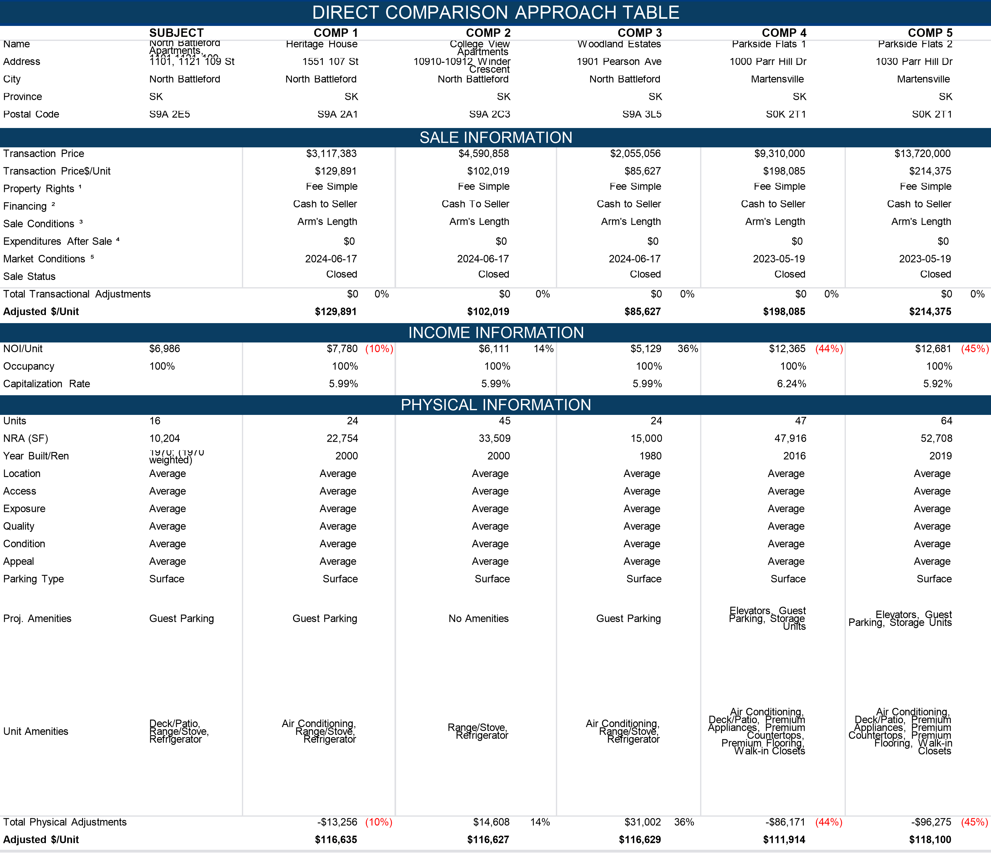

Sales Comparison Approach Analysis

In our opinion, a buyer’s criteria for the purchase of properties such as the subject are predicated primarily on the property’s net income characteristics.  Thus, we have identified a relationship between the net operating income and the sales price of the subject and the comparables.  The income analysis accounts for differences between the comparables and the subject relative to differences in location, construction quality, age/condition, exposure, access and other physical characteristics.  Inferior properties generally achieve lower rent levels resulting in a lower net operating income per square foot.

In this method, we have compared the sales to the subject primarily along economic lines rather than on physical characteristics.  Economic measures such as the relationship of sales price to net operating income are inclusive of all the physical and economic attributes of a property.

Based on the preceding, we have trended the subject properties projected NOI per square foot and unit against the comparable properties NOI per square foot and unit and sale price per square foot and unit to estimate a value per unit for the subject property.

Based on general bracketing, the comparable sales support an adjusted unit value ranges from $111,914/Unit to $118,100/Unit, with a unit value of $112,500/Unit concluded for the subject property. The following table summarizes the analysis of the comparables, reports the reconciled price per Unit value conclusion, and presents the concluded value of the subject property by the Sales Comparison Approach.

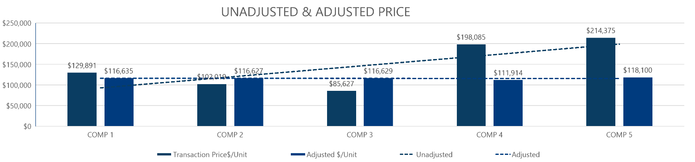

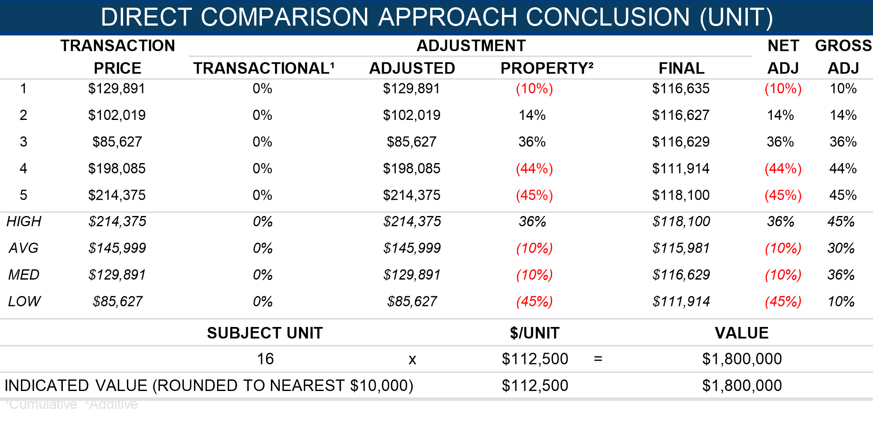

Sales Comparison Approach Conclusion

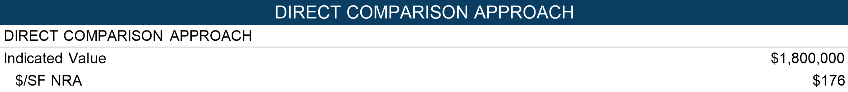

Reconciliation of Value

Based on the agreed upon scope with the authorized client, the subject’s specific characteristics and the interest appraised, this appraisal developed Direct Comparison and Income (Direct Capitalization) Approaches. The values presented represent the As Stabilized (Fee Simple Estate).

The Reconciliation of Value Conclusions is the final step in the appraisal process and involves the weighing of the individual valuation techniques in relationship to their substantiation by market data, and the reliability and applicability of each valuation technique to the subject property. Below, the individual strengths and weaknesses of each approach are analyzed.

As previously discussed, the **Cost Approach** was not presented in this analysis. This approach has limited application due to the age of the improvements and lack of market-based evidence to support accrued depreciation. Additionally, investors typically do not place emphasis on replacement cost in establishing value for investment properties. The exclusion of the Cost Approach does not diminish the credibility of the value conclusion.

The price per unit method has been presented in the **Sales Comparison Approach**. There have been several recent sales of properties similar to the subject in the market area in the current market conditions, which increases the validity of this approach. The most likely buyer for the subject would be an investor and this approach is given less weight.

The **Income Approach** to value is generally considered to be the best and most accurate measure of the value of income-producing properties. The value estimate by this approach best reflects the analysis that knowledgeable buyers and sellers carry out in their decision-making processes regarding this type of property. Sufficient market data was available to reliably estimate gross income, vacancy, expenses and capitalization rates for the subject property. The subject is fully leased to multiple tenants as of the effective date of valuation. The most likely buyer is an investor, suggesting this approach deserves primary emphasis.

After considering all factors relevant to the valuation of the subject property, sole emphasis is placed on the Income (Direct Capitalization) Approach in the following market value.

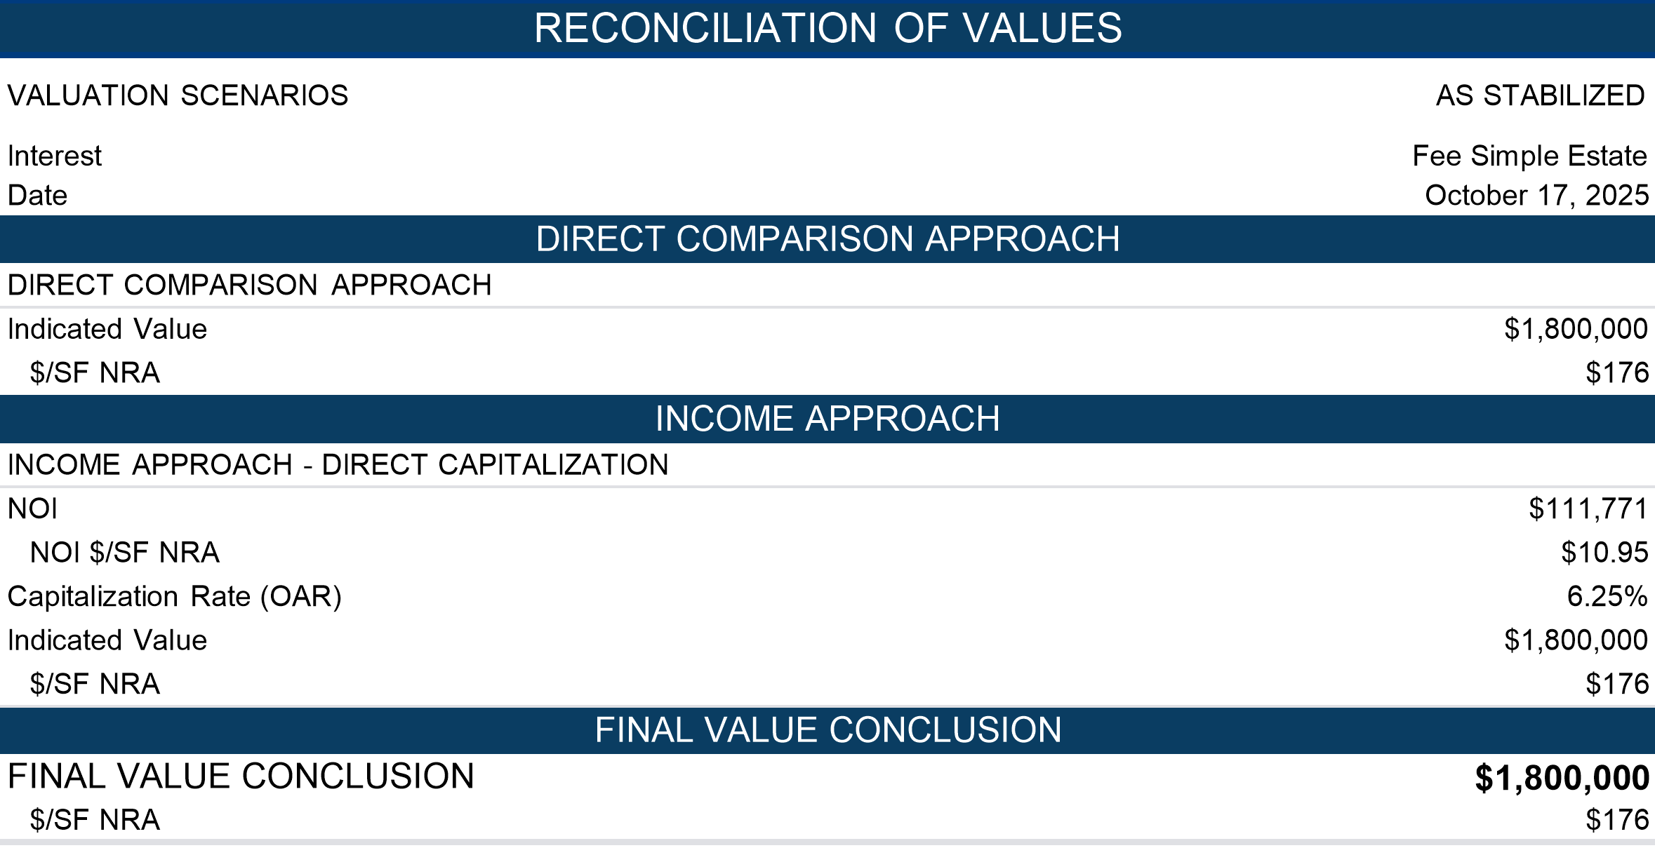

Hypothetical Conditions

The use of a hypothetical condition(s) may have impacted the results of the assignment. The As Stabilized value has been developed based on the hypothetical condition that the subject property is fully leased at prevailing market rents and has achieved stabilized occupancy as of the effective date of the appraisal. Under this premise, no deductions are made for holding costs, rent loss, or lease-up expenses. In addition it is a hypothetical condition that all units could achieve current market rent levels and stabilized occupancy as of the effective date. In reality, as of the effective date, the property's existing lease terms reflect contract rents that are deemed to be below-market rents. For the purposes of this analysis, it is assumed that lease-up to market rent levels has occurred under typical market conditions, without undue delay or concessions exceeding market norms. If this assumption proves incorrect, such as market rents are not achievable the value conclusion may be materially impacted.

Extraordinary Assumptions

No Extraordinary Assumptions were made for this assignment.

Extraordinary Limiting Conditions

No Extraordinary Limiting Conditions were made for this assignment.

Certification

We certify that, to the best of our knowledge and belief:

1. The statements of fact contained in this report are true and correct.
2. The reported analyses, opinions and conclusions are limited only by the reported assumptions and limiting conditions and are our impartial and unbiased professional analyses, opinions and conclusions.
3. We have no past, present or prospective interest in the property that is the subject of this report and no personal and/or professional interest or conflict with respect to the parties involved with this assignment.
4. We have no bias with respect to the property that is the subject of this report or to the parties involved with this assignment.
5. Our engagement in and compensation is not contingent upon developing or reporting predetermined results, the amount of value estimate, a conclusion favouring the authorized client, or the occurrence of a subsequent event.
6. Our analyses, opinions and conclusions were developed, and this report has been prepared, in conformity with the CUSPAP.
7. We have the knowledge and experience to complete this assignment competently.
8. Except as herein disclosed, no one has provided significant professional assistance in the preparation of this appraisal.
9. As of the date of this report we have fulfilled the requirements of the AIC’s Continuing Professional Development Program.
10. We are members in good standing of the Appraisal Institute of Canada.
11. For this appraisal to be valid, an original or a password protected digital signature is required.

Final Estimate of Value

Based upon the data, analyses and conclusions contained herein, the market value of the fee simple estate in the subject property is concluded as follows:



Hypothetical Conditions

The use of a hypothetical condition(s) may have impacted the results of the assignment. The As Stabilized value has been developed based on the hypothetical condition that the subject property is fully leased at prevailing market rents and has achieved stabilized occupancy as of the effective date of the appraisal. Under this premise, no deductions are made for holding costs, rent loss, or lease-up expenses. In addition it is a hypothetical condition that all units could achieve current market rent levels and stabilized occupancy as of the effective date. In reality, as of the effective date, the property's existing lease terms reflect contract rents that are deemed to be below-market rents. For the purposes of this analysis, it is assumed that lease-up to market rent levels has occurred under typical market conditions, without undue delay or concessions exceeding market norms. If this assumption proves incorrect, such as market rents are not achievable the value conclusion may be materially impacted.

Extraordinary Assumptions

No Extraordinary Assumptions were made for this assignment.

Extraordinary Limiting Conditions

No Extraordinary Limiting Conditions were made for this assignment.

|  |  |
| --- | --- |
| Chris Chornohos, AACI, MRICS  Founder  chris.chornohos@valta.ca |  |
| AIC No: 90209 |  |

Appendices

Contingent & Limiting Conditions

Assumptions, Limiting Conditions, Disclaimers and Limitations of Liability

The certification that appears in the appraisal report is subject to compliance with the Canadian Uniform Standards of Professional Appraisal Practice (“CUSPAP”) and the following conditions:

1. This report is prepared only for Authorized Client and authorized users specifically identified in this report and only for the specific use identified herein. No other person may rely on this report or any part of this report without first obtaining consent from Authorized Client and written authorization from the authors. Liability is expressly denied to any other person and, accordingly, no responsibility is accepted for any damage suffered by any other person as a result of decisions made or actions taken based on this report. Liability is expressly denied for any unauthorized user or for anyone who uses this report for any use not specifically identified in this report. Payment of the appraisal fee has no effect on liability. Reliance on this report without authorization or for an unauthorized use is unreasonable.
2. Because market conditions, including economic, social and political factors, may change rapidly and, on occasion, without warning, this report cannot be relied upon as of any date other than the effective date specified in this report unless specifically authorized by the author(s).
3. The author will not be responsible for matters of a legal nature that affect either the property being appraised or the title to it. The property is appraised on the basis of it being under responsible ownership. No registry office search has been performed and the author assumes that the title is good and marketable and free and clear of all encumbrances. Matters of a legal nature, including confirming who holds legal title to the appraised property or any portion of the appraised property, are outside the scope of work and expertise of the appraiser. Any information regarding the identity of a property’s owner or identifying the property owned by the listed client and/or applicant provided by the appraiser is for informational purposes only and any reliance on such information is unreasonable. Any information provided by the appraiser does not constitute any title confirmation. Any information provided does not negate the need to retain a real estate lawyer, surveyor or other appropriate experts to verify matters of ownership and/or title.
4. Verification of compliance with governmental regulations, bylaws or statutes is outside the scope of work and expertise of the appraiser. Any information provided by the appraiser is for informational purposes only and any reliance is unreasonable. Any information provided by the appraiser does not negate the need to retain an appropriately qualified professional to determine government regulation compliance.
5. No survey of the property has been made. Any sketch in this report shows approximate dimensions and is included only to assist the reader of this report in visualizing the property. It is unreasonable to rely on this report as an alternative to a survey, and an accredited surveyor ought to be retained for such matters.
6. This report is completed on the basis that testimony or appearance in court concerning this report is not required unless specific arrangements to do so have been made beforehand. Such arrangements will include, but not necessarily be limited to: adequate time to review the report and related data, and the provision of appropriate compensation.
7. Unless otherwise stated in this report, the author has no knowledge of any hidden or unapparent conditions (including, but not limited to: its soils, physical structure, mechanical or other operating systems, foundation, etc.) of/on the subject property or of/on a neighbouring property that could affect the value of the subject property. It has been assumed that there are no such conditions. Any such conditions that were visibly apparent at the time of inspection or that became apparent during the normal research involved in completing the report have been noted in the report. This report should not be construed as an environmental audit or detailed property condition report, as such reporting is beyond the scope of this report and/or the qualifications of the author. The author makes no guarantees or warranties, express or implied, regarding the condition of the property, and will not be responsible for any such conditions that do exist or for any engineering or testing that might be required to discover whether such conditions exist. The bearing capacity of the soil is assumed to be adequate.
8. The author is not qualified to comment on detrimental environmental, chemical or biological conditions that may affect the market value of the property appraised, including but not limited to pollution or contamination of land, buildings, water, groundwater or air which may include but are not limited to moulds and mildews or the conditions that may give rise to either. Any such conditions that were visibly apparent at the time of inspection or that became apparent during the normal research involved in completing the report have been noted in the report. It is an assumption of this report that the property complies with all regulatory requirements concerning environmental, chemical and biological matters, and it is assumed that the property is free of any detrimental environmental, chemical legal and biological conditions that may affect the market value of the property appraised. If a party relying on this report requires information about or an assessment of detrimental environmental, chemical or biological conditions that may impact the value conclusion herein, that party is advised to retain an expert qualified in such matters. The author expressly denies any legal liability related to the effect of detrimental environmental, chemical or biological matters on the market value of the property.
9. The analyses set out in this report relied on written and verbal information obtained from a variety of sources the author considered reliable. Unless otherwise stated herein, the author did not verify client-supplied information, which the author believed to be correct.
10. The term “inspection” refers to observation only as defined by CUSPAP and reporting of the general material finishing and conditions observed for the purposes of a standard appraisal inspection. The inspection scope of work includes the identification of marketable characteristics/amenities offered for comparison and valuation purposes only.
11. The opinions of value and other conclusions contained herein assume satisfactory completion of any work remaining to be completed in a good and workmanlike manner. Further inspection may be required to confirm completion of such work. The author has not confirmed that all mandatory building inspections have been completed to date, nor has the availability/issuance of an occupancy permit been confirmed. The author has not evaluated the quality of construction, workmanship or materials. It should be clearly understood that this visual inspection does not imply compliance with any building code requirements as this is beyond the professional expertise of the author.
12. The contents of this report are confidential and will not be disclosed by the author to any party except as provided for by the provisions of the CUSPAP and/or when properly entered into evidence of a duly qualified judicial or quasi-judicial body. The author acknowledges that the information collected herein is personal and confidential and shall not use or disclose the contents of this report except as provided for in the provisions of the CUSPAP and in accordance with the author’s privacy policy. Authorized Client agrees that in accepting this report, it shall maintain the confidentiality and privacy of any personal information contained herein and shall comply in all material respects with the contents of the author's privacy policy and in accordance with the PIPEDA.
13. The author has agreed to enter into the assignment as requested by Authorized Client named in this report for the use specified by Authorized Client, which is stated in this report. Authorized Client has agreed that the performance of this report and the format are appropriate for the authorized use.
14. This report, its content and all attachments/addendums and their content are the property of the author. Authorized Client, authorized users and any appraisal facilitator are prohibited, strictly forbidden, and no permission is expressly or implicitly granted or deemed to be granted, to modify, alter, merge, publish (in whole or in part) screen scrape, database scrape, exploit, reproduce, decompile, reassemble or participate in any other activity authorized to separate, collect, store, reorganize, scan, copy, manipulate electronically, digitally, manually or by any other means whatsoever this appraisal report, addendum, all attachments and the data contained within for any commercial, or other use.
15. If transmitted electronically, this report will have been digitally signed and secured with personal passwords to lock the appraisal file. Due to the possibility of digital modification, only originally signed reports and those reports sent directly by the author can be reasonably relied upon.
16. Where the authorized use of this report is for financing or mortgage lending or mortgage insurance, it is a condition of reliance on this report that the authorized user has or will conduct lending, underwriting and insurance underwriting and rigorous due diligence in accordance with the standards of a reasonable and prudent lender or insurer, including but not limited to ensuring the borrower’s demonstrated willingness and capacity to service his/her debt obligations on a timely basis, and to conduct loan underwriting or insuring due diligence similar to the standards set out by the Office of the Superintendent of Financial Institutions (OSFI), even when not otherwise required by law. Liability is expressly denied to those that do not meet this condition. Any reliance on this report without satisfaction of this condition is unreasonable.
17. In the event that a party entitled to do so, makes a claim against Valta or any of its affiliates or any of their respective officers or employees in connection with or in any way relating to this engagement of the Appraisal, the maximum damages recoverable from Valta or any of its parent companies or their respective officers or employees shall be the amount of the monies actually collected by us for this assignment and under no circumstances shall any claim for consequential damages be made. In the event that our invoice remains unpaid and we must enlist the assistance of a collection agency, you agree to pay the fees for collection in addition to attorney’s fees.
18. Values contained in this appraisal are based on market conditions as at the time of this report. This appraisal does not provide a prediction of future values. In the event of market instability and/or disruption, values may change rapidly and such potential future events have NOT been considered in this report. As this appraisal does not and cannot consider any changes to the property appraised or market conditions after the effective date, readers are cautioned in relying on the appraisal after the effective date noted herein.

Definition of Terms

* + **Absorption Period:** The actual or expected period required from the time a property, group of properties, or commodity is initially offered for lease, purchase, or use by its eventual users until all portions have been sold or stabilized occupancy has been achieved.
  + **Absorption Rate:** 1) Broadly, the rate at which vacant space in a property or group of properties for sale or lease has been or is expected to be successfully sold or leased over a specified period of time. 2) In subdivision analysis, the rate of sales of lots or units in a subdivision.
  + **Ad Valorem Tax:** A tax levied in proportion to the value of the thing(s) being taxed. Exclusive of exemptions, use-value assessment provisions, and the like, the property tax is an ad valorem tax. (International Association of Assessing Officers [IAAO])
  + **Assessed Value:** A value set on real estate and personal property by a government as a basis for levying taxes. Assessed value is a certified value identified on an assessment roll produced by an Assessment Jurisdiction and is typically defined by statutes and regulations in each respective Province.
  + **Authorized Client:** The individual or organization for whom the Member renders or agrees to render Professional Services.
  + **Authorized Use:** The use of a Member’s Professional Services, as identified and authorized by the Member based on communication between the Member and the Authorized Client.
  + **Authorized User:** A party identified by name and authorized as a user of the Professional Services of the Member, based on communication between the Member and the Authorized Client.
  + **Cash Equivalency:** An analytical process in which the sale price of a transaction with nonmarket financing or financing with unusual conditions or incentives is converted into a price expressed in terms of cash or its equivalent.
  + **Contract Rent:** The actual rental income specified in a lease.
  + **Disposition Value:** The most probable price that a specified interest in property should bring under the following conditions: 1) Consummation of a sale within a specified time, which is shorter than the typical exposure time for such a property in that market. 2) The property is subjected to market conditions prevailing as of the date of valuation. 3) Both the buyer and seller are acting prudently and knowledgeably. 4) The seller is under compulsion to sell. 5) The buyer is typically motivated. 6) Both parties are acting in what they consider to be their best interests. 7) An adequate marketing effort will be made during the exposure time. 8) Payment will be made in cash in Canadian dollars (or the local currency) or in terms of financial arrangements comparable thereto. 9) The price represents the normal consideration for the property sold, unaffected by special or creative financing or sales concessions granted by anyone associated with the sale. This definition can also be modified to provide for valuation with specified financing terms.
  + **Effective Rent:** Total base rent, or minimum rent stipulated in a lease, over the specified lease term minus rent concessions; the rent that is effectively paid by a tenant net of financial concessions provided by a landlord.
  + **Excess Land:** Land that is not needed to serve or support the existing use. The highest and best use of the excess land may or may not be the same as the highest and best use of the improved parcel. Excess land has the potential to be sold separately and is valued separately. See also surplus land.
  + **Excess Rent:** The amount by which contract rent exceeds market rent at the time of the appraisal; created by a lease favorable to the landlord (lessor) and may reflect unusual management, unknowledgeable or unusually motivated parties, a lease execution in an earlier, stronger rental market, or an agreement of the parties.
  + **Exposure Time:** The estimated length of time the property interest being appraised would have been offered on the market before the hypothetical consummation of a sale at the estimated value on the Effective Date of the appraisal. Exposure time is backward-looking.
  + **Extraordinary Assumption:** An assumption, directly related to a specific Assignment, which, if were not assumed to be true, could materially alter the opinions or conclusions. Extraordinary Assumptions presume uncertain information about or anticipated changes in: the physical, legal or economic characteristics of the subject property; or about: conditions external to the subject property such as market conditions or trends, or the integrity of data used in an analysis to be fact.
  + **Fee Simple Estate:** Absolute ownership unencumbered by any other interest or estate, subject only to the limitations imposed by the governmental powers of taxation, eminent domain, police power, and escheat.
  + **Floor Area Ratio (FAR):** The relationship between the above-ground floor area of a building, as described by the zoning or building code, and the area of the plot on which it stands; in planning and zoning, often expressed as a decimal, e.g., a ratio of 2.0 indicates that the permissible floor area of a building is twice the total land area.
  + **Frictional Vacancy:** The amount of vacant space needed in a market for its orderly operation. Frictional vacancy allows for move-ins and move-outs.
  + Full Service Lease: See gross lease.
  + **General Vacancy:** A method of calculating any remaining vacancy and collection loss considerations when using discounted cash flow (DCF) analysis, where turnover vacancy has been used as part of the income estimate. The combined effects of turnover vacancy and general vacancy relate to total vacancy and collection loss.
  + **Going-Concern Premise:** One of the premises under which the total assets of a business can be valued; the assumption that a company is expected to continue operating well into the future (usually indefinitely).
  + **Going Concern Value:** An outdated label for the market value of all the tangible and intangible assets of an established and operating business with an indefinite life, as if sold in aggregate; more accurately termed the market value of the going concern or market value of the total assets of the business.
  + **Gross Building Area (GBA):** 1) Total floor area of a building, excluding unenclosed areas, measured from the exterior of the walls of the above grade area. This includes mezzanines and basements if and when typically included in the market area of the type of property involved. 2) Gross leasable area plus all common areas. 3) For residential space, the total area of all floor levels measured from the exterior of the walls and including the superstructure and substructure basement; typically does not include garage space.
  + **Gross Lease:** A lease in which the landlord receives stipulated rent and is obligated to pay all of the property’s operating and fixed expenses; also called full-service lease.
  + **Hypothetical Condition:** Hypothetical Conditions are a specific type of an Extraordinary Assumption that presumes, as fact, simulated but untrue information about physical, legal, or economic characteristics of the subject property or external conditions, and are imposed for purposes of reasonable analysis.
  + **Investment Value:** 1) The value of a property to a particular investor or class of investors based on the investor’s specific requirements. Investment value may be different from market value because it depends on a set of investment criteria that are not necessarily typical of the market. 2) The value of an asset to the owner or a prospective owner for individual investment or operational objectives. (International Valuation Standards [IVS])
  + **Land-to-Building Ratio:** The proportion of land area to gross building area; one of the factors determining comparability of properties.
  + **Lease:** A legal agreement that grants the right to use, occupy, or control all or part of a property for a stated period of time based on the terms and covenants of the Lease including but not limited to: the rental rate.
  + **Leased Fee Interest:** The ownership interest held by the lessor, which includes the right to receive the contract rent specified in the lease plus the reversionary right when the lease expires.
  + **Leasehold Interest:** The right held by the lessee to use and occupy real estate for a stated term and under the conditions specified in the lease.
  + **Lessee:** One who has the right to occupancy and use of the property of another for a period of time according to a lease agreement.
  + **Lessor:** One who conveys the rights of occupancy and use to others under a lease agreement.
  + **Liquidation Value:** The most probable price that a specified interest in property should bring under the following conditions: 1) Consummation of a sale within a short time period. 2) The property is subjected to market conditions prevailing as of the date of valuation. 3) Both the buyer and seller are acting prudently and knowledgeably. 4) The seller is under extreme compulsion to sell. 5) The buyer is typically motivated. 6) Both parties are acting in what they consider to be their best interests. 7) A normal marketing effort is not possible due to the brief exposure time. 8) Payment will be made in cash in Canadian dollars (or the local currency) or in terms of financial arrangements comparable thereto. 9) The price represents the normal consideration for the property sold, unaffected by special or creative financing or sales concessions granted by anyone associated with the sale. This definition can also be modified to provide for valuation with specified financing terms.
  + **Market Rent:** The most probable rent that a property should bring in a competitive and open market reflecting the conditions and restrictions of a specified lease agreement, including the rental adjustment and revaluation, permitted uses, use restrictions, expense obligations, term, concessions, renewal and purchase options, and tenant improvements (TIs).
  + **Market Value:** The most probable price, as of a specified date, in cash, or in terms equivalent to cash, or in other precisely revealed terms, for which the specified property rights should sell after reasonable exposure in a competitive market under all conditions requisite to a fair sale, with the buyer and the seller each acting prudently, knowledgeably, and for self-interest, and assuming that neither is under undue duress.
  + **Market Value of the Going Concern:** The market value of an established and operating business including the real property, personal property, financial assets, and the intangible assets of the business.
  + **Marketing Time:** Marketing Time is an opinion on the amount of time it might take to sell a property interest in Real Estate at the concluded estimate of Market Value during the period immediately after the Effective Date of an appraisal. Marketing Time is forward-looking and predictive.
  + **Modified Gross Lease:** A lease in which the landlord receives stipulated rent and is obligated to pay some, but not all, of the property’s operating and fixed expenses. Since assignment of expenses varies among modified gross leases, expense responsibility must always be specified. In some markets, a modified gross lease may be called a double net lease, net net lease, partial net lease, or semi-gross lease.
  + **Net Lease:** A lease in which the landlord passes on all expenses to the tenant. See also **gross lease; modified gross lease**.
  + **Net Net Net Lease:** An alternative term for a type of net lease. In some markets, a net net net lease is defined as a lease in which the tenant assumes all expenses (fixed and variable) of operating a property except that the landlord is responsible for structural maintenance, building reserves, and management; also called NNN lease, triple net lease, or fully net lease.
  + **Occupancy Rate:** 1) The relationship or ratio between the potential income from the currently rented units in a property and the income that would be received if all the units were occupied. 2) The ratio of occupied space to total rentable space in a building.
  + **Overage Rent:** The percentage rent paid over and above the guaranteed minimum rent or base rent; calculated as a percentage of sales in excess of a specified breakpoint sales volume.
  + **Percentage Rent:** Rental income received in accordance with the terms of a percentage lease; typically derived from retail store and restaurant tenants and based on a certain percentage of their gross sales.
  + **Prospective Opinion of Value:** A value opinion effective as of a specified future date. The term does not define a type of value. Instead, it identifies a value opinion as being effective at some specific future date. An opinion of value as of a prospective date is frequently sought in connection with projects that are proposed, under construction, or under conversion to a new use, or those that have not yet achieved sellout or a stabilized level of long-term occupancy.
  + **Rentable Area:** For office or retail buildings, the tenant’s pro rata portion of the entire office floor, excluding elements of the building that penetrate through the floor to the areas below. The rentable area of a floor is computed by measuring to the inside finished surface of the dominant portion of the permanent building walls, excluding any major vertical penetrations of the floor. Alternatively, the amount of space on which the rent is based; calculated according to local practice.
  + **Retrospective Value Opinion:** A value opinion effective as of a specified historical date. The term retrospective does not define a type of value. Instead, it identifies a value opinion as being effective at some specific prior date. Value as of a historical date is frequently sought in connection with property tax appeals, damage models, lease renegotiation, deficiency judgments, estate tax, and condemnation. Inclusion of the type of value with this term is appropriate, e.g., “retrospective market value opinion.”
  + **Shell Rent:** The typical rent paid for retail, office, or industrial tenant space based on minimal “shell” interior finishes (called vanilla finish or white wall finish in some areas). Usually the landlord delivers the main building shell space or some minimum level of interior build-out, and the tenant completes the interior finish, which can include wall, ceiling, and floor finishes, mechanical systems, interior electricity, and plumbing. Typically these are long-term leases with tenants paying all or most property expenses.
  + **Surplus Land:** Land that is not currently needed to support the existing use but cannot be separated from the property and sold off for another use. Surplus land does not have an independent highest and best use and may or may not contribute value to the improved parcel. See also excess land.
  + **Turnover Vacancy:** A method of calculating vacancy allowance that is estimated or considered as part of the potential income estimate when using discounted cash flow (DCF) analysis. As units or suites turn over and are available for re-leasing, the periodic vacancy time frame (vacancy window) to release the space is considered.
  + **Usable Area:** 1) For office buildings, the actual occupiable area of a floor or an office space; computed by measuring from the finished surface of the office side of corridor and other permanent walls, to the center of partitions that separate the office from adjoining usable areas, and to the inside finished surface of the dominant portion of the permanent outer building walls. Sometimes called net building area or net floor area. See also floor area. 2) The area that is actually used by the tenants measured from the inside of the exterior walls to the inside of walls separating the space from hallways and common areas.
  + **Use Value:** The value of a property assuming a specific use, which may or may not be the property’s highest and best use on the effective date of the appraisal. Use value may or may not be equal to market value but is different conceptually. See also **value in use**.
  + **Value In Use:** The value of a property assuming a specific use, which may or may not be the property’s highest and best use on the effective date of the appraisal. Value in use may or may not be equal to market value but is different conceptually. See also **use value**.
  + **Value Indication:** A valuer’s conclusion of value resulting from the application of an approach to value, e.g., the value indication by the sales comparison approach.

Qualifications of the Appraiser



**Valta Property Valuations Ltd.**

300, 4838 Richard Road SW

Calgary, AB T3E 6L1

**Office:** 587-801-5151